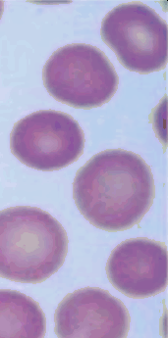

1. A 30-year-old man comes to the physician because of a 2-month history of episodes of headache, fever, and shaking chills since he returned from a 6-month trip

to the Mayan ruins in southern Mexico. His temperature is 39°C (102.2oF). Physical

examination shows no other abnormalities. A photomicrograph of a Wright-stained peripheral blood smear is shown. Which of the following vectors is the most likely source of infection in this patient?

1. Body louse
2. Kissing bug
3. **Sandfly**
4. Tsetse fly

The Correct Answer is : C. **Mosquito**

# The patient's symptoms of headache, fever, and shaking chills along with his recent travel to southern Mexico, are suggestive of malaria. Malaria is caused by Plasmodium species, which are transmitted to humans through the bite of infected Anopheles mosquitoes.

1. A 67-year-old man comes to the physician because of numbness in his hands and feet for 3 months. Vitamin B12 (cobalamin) deficiency is suspected. An increased serum concentration of which of the following is  likely to confirm the diagnosis?

E

* 1. Acetoacetate
  2. Alanine
  3. Leucine
  4. Methionine

F. lactate

The Correct Answer is : E. Methylmalonate

# Vitamin B12 deficiency can be confirmed by an increased serum concentration of methylmalonate. Vitamin B12 is a cofactor for the enzyme methylmalonyl-CoA mutase, which converts methylmalonyl-CoA to succinyl-CoA. In the case of vitamin B12 deficiency this conversion is impaired, leading to an accumulation of methylmalonate in the serum.

1. A 35-year-old man is brought to the emergency department 30 minutes after fainting while at work. He is conscious and is able to state his name and what he was doing before the episode. He says that he has had fatigue during the past 3 weeks. He has no history of major medical illness and takes no medications. His mother died of ovarian cancer at the age of 40 years. His maternal grandfather died of colon cancer at the age of 49 years. The patient does not smoke or drink alcoholic beverages. He

appears pale. His temperature is 3z oc ( 9.5°F), pulse is 110/min, respirations are

20/min, and blood pressure is 95/55 mm Hg. Physical examination shows no other abnormalities. Laboratory studies show a hemoglobin concentration of 6.2 g/dL and hematocrit of 19%. Test of the stool for occult blood is positive. Colonoscopy shows an isolated right-sided Examination of a biopsy specimen of the shows a poorly-differentiated adenocarcinoma with mucinous features. lmmunohistochemistry of the biopsy specimen is most likely to show loss of expression of which of the following proteins?

E

E

1. BRCA1
2. B-Catenin
3. 2
4. pM

The Correct Answer is : D. MSH2

The patient's family history of early-onset ovarian and colon cancers suggests the possibility of Lynch syndrome (also known as hereditary nonpolyposis colorectal cancer, or HNPCC). This condition is caused by germline mutations in DNA mismatch repair genes, most commonly MSH2 and MLH1.

Immunohistochemistry of the biopsy specimen would most likely show loss of expression of MSH2 in this case.

1. A 56-year-old woman comes to the physician because of progressive shortness of breath and cough during the past 2 weeks. Her respirations are 20/min. Crackles are heard on auscultation. A chest x-ray shows bilateral pleural effusions. A thoracentesis is done. Pleural fluid analysis shows:

Appearance

Specific gravity Protein

translucent mildly

**yellow**

1.00

* 1. dL

Mesothelial cells 5/mm’

Lymphocytes hmm’

Which of the following is the most likely underlying cause of the findings in this patient?

* + 1. Metastatic carcinoma to the lung
    2. Pulmonary tuberculosis
    3. systemic lupus erythematosus
    4. Thoracic duct obstruction
    5. Bacterial pneumonia

The Correct Answer is : **A. Congestive** heart failure

The patient's pleural fluid analysis results are consistent with a transudative pleural effusion, which has low protein and cell counts. Congestive heart failure is the most common cause of transudative pleural effusions. The translucent, mildly yellow appearance and low specific gravity also support this diagnosis.

1. An investigator is studying the cellular responses that follow different types of injury to the liver. In the experimental model, animals are exposed to a toxin that kills 50% of the hepatocytes, but spares injury to the basement membrane and underlying extracellular matrix of the liver. The cellular response to this injury will primarily occur via which of the following mechanisms?
   1. Activation of liver stem cells
2. Increased production of extracellular matrix
3. lngroMh of granulation tissue into the liver
4. Recruitment of fibroblasts to the liver

The Correct Answer is : B. Entry of hepatocytes into the cell cycle

Following liver injury that spares the basement membrane and underlying extracellular matrix, hepatocytes will enter the cell cycle to regenerate and replace the damaged cells. This process is known as compensatory hyperplasia. The liver has a remarkable ability to regenerate itself and hepatocytes can rapidly proliferate in response to injury or loss of liver tissue.

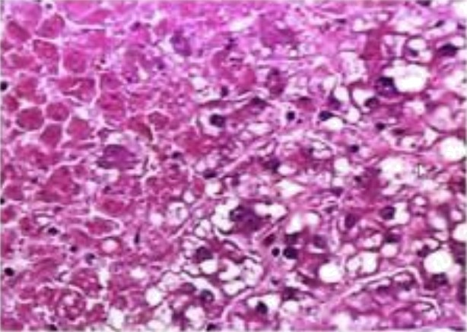

1. A 26-year-old woman is brought to the emergency department 30 minutes after a neighbor found her lying unresponsive on her kitchen floor. She is pronounced dead on arrival. She had no history of any major medical illness. At autopsy, the liver size is two- thirds normal with a wrinkled capsule and soft, hyperemic parenchyma. A photomicrograph of a section of the liver is shown. The hepatic changes ale most suggestive of which of the following types of damage?
   1. Drug toxicity
2. Neoplasia
3. Radiation Injury
4. Trauma

The Correct Answer is : B. Hypoxia

The description of the liver (smaller in size, wrinkled capsule, soft, hyperemic parenchyma, and bubbling cells) is most suggestive of hypoxic damage. Hypoxia refers to a state in which there is a lack of oxygen supply to the tissue. This can result from various causes, such as cardiac arrest, respiratory failure, *or* carbon monoxide poisoning, leading to cellular damage and eventually tissue death.

1. An 84-year-old man is brought to the emergency department 30 minutes after an episode of syncope. Transthoracic echocardiography shows a 4-cm

E

E

occupying the majority of the left atrium. The will be excised using a robotically assisted operation via an oblique right atriotomy and transection of the interatrial septum. When making the incision into the left atrium to remove the myxoma, which of the following regions of the interatrial septum should be avoided in order to prevent injury to the cardiac conduction system?

E*

* 1. Crista terminall9
  2. FO99a OValis region
  3. Posteroliderlor region above the opening of the coronary sinus



E. superoposterior region posterior to the fo99a OValis

The Correct Answer is : D. Superoanterior region above the limbus of the fossa ovalis

The incision should avoid the superoanterior region above the limbus of the fossa ovalis to prevent injury to the cardiac condu ion system. The atrioventricular (AV) node is located in this region and can be injured if the incision is made too close.

1. A 68-year-old woman comes to the physician for a follow-up examination after a routine endoscopy for dyspepsia showed large esophageal varices. She has a

25-year history of type 2 diabetes mellitus. She also has hypertension and hyperlipidemia. She does not have any history of liver disease, blood transfusions, or intravenous drug use, and she does not drink alcohol. Her current medications are

81-mg aspirin, insulin, lisinopril, and simvastatin. She appears alert. She is 168 cm (5 ft 6 in) tall and weighs 110 kg (242 lb); BMI is 39  Physical examination shows scattered spider angiomata over the chest and upper extremities. Abdominal examination shows no ascites. The spleen tip is palpated 4 cm below the left costal margin. Laboratory studies show

Hemoglobin 12.2 g/dL

Hematocrit

Mean corpuscular volume

Platelet count

102 km’

92,000 mm’ Serum

# Total bilirubin

AST

## ALT

1.8 mg/dL





Ferritin

62 ng/mL

negative

**Hepatitis** B surface antigen

**Hepatitis** B surface antibody

positive

Hepatitis C virus negative

Ultrasonography shows coarsened liver echotexture with increased echogenicity. Which of the following is the most likely cause of the liver findings in this patient?

1. Adverse drug ef1ect
2. Chronic hepatitis
3. Hepatolenticular degeneration (Wilson disease)
4. Prior excessive alcohol use

The Correct Answer is : C. Fatty liver

# This patient has a history of obesity, type 2 diabetes mellitus hypertension and hyperlipidemia, which are all risk factors for non-alcoholic fatty liver disease (NAFLD). The coarsened liver echotexture with increased echogenicity on ultrasonography is consistent with fatty liver. The other options are less likely given the patient's medical history and laboratory findings.

1. A 54-year-old man comes to the physician because of a 4-month history of progressive shortness of breath and left-sided chest pain; he also has had an unintentional 11-kg (25-lb) weight loss during this period. His temperature is 37°C

(98. oF), pulse is 92/min, respirations are 32/min, and blood pressure is 118/72 mm

Hg. Breath sounds are decreased over the left lung field. A chest x-ray-shows a left

pleural effusion with a pleural-based mass encasing the left lung. A thoracentesis is done. Analysis of pleural fluid shows cytologically malignant cells that express calretinin Which of the following best describes the cell of origin of this neoplasm?

1. Club cells
2. Lymphoid cells

C Mesoth•flal cells

1. Neuroendocrine cells
2. squamous metaplastic cells

The Correct Answer is : C. Mesothelial cells

# The presence of cytologically malignant cells expressing calretinin in the pleural fluid suggests a diagnosis of malignant mesothelioma. Mesotheliomas originate from mesothelial cells, which line the pleural, peritoneal, and pericardial cavities.







1. A 63-year-old man with a long history of sun exposure develops the skin lesion shown. Which of the following is the most likely diagnosis?
   1. Actinic keratosis
2. seborrheic keratosis
3. Malignant melanoma
4. squamous cell carcinoma

The Correct Answer is : B. Basal cell carcinoma

Given the age of the patient, long history of sun exposure and the description of the skin lesion as a pearly, translucent or waxy bump the most likely diagnosis is:

B) Basal cell carcinoma

Basal cell carcinoma (BCC) is the most common type of skin cancer and is often associated with sun exposure. BCC typically presents as a pearly translucent, or waxy bump, often with visible blood vessels. It is a slow-growing cancer that rarely spreads to other parts of the body but can be locally invasive and cause damage to surrounding tissues if left untreated.

1. A 54-year-old man is brought to the emergency department by his wife 2 hours after the onset of severe chest pain. After being evaluated by the physician, he is told that he has had an acute myocardial infarction. While the physician is explaining the diagnosis, the patient exclaims, "I knew it I knew it! I'm going to die. My wife will be a widow. My kids will go hungry and be homeless." After acknowledging that he understands the patient's concerns, it is most appropriate for the physician to state which of the following?

+••+•=+•‹•z••

B"R.ight now, it's really important that you think positively and keep your spirits up."

1. "We have some literature available to you that will help you cope with your diagnosis."
2. "Would you like to speak with your wife about these fears that you are having?"
3. "You need to calm down so that I can explain your situation and potential treatment options more fully."

The Correct Answer is : A. "Being sick can be very frightening, especially when you have people who depend on you"

# Empathizing with the patient and acknowledging his concerns is the most appropriate approach in this situation. This response validates the patient's feelings and opens the door for further conversation and reassurance.

 

The Crzmnt Ann ie . A. aeztea

A ea+dy rg To @k+rita wiih area aziphyeazia treated wiki oreJ biaophylline 1ts 19 wee a tithe a



## clrcumecñbnd wffi mRlmol muc 1•hnmitmis. A Kyle of e6&

e 'omol armor 1s met €urtfim azomlrotton of tfils tumor 1s mon Qty to chew wff•b



QA Tal triAra {Q ISTa) aia rn+at rzaomouly aeeo•niand with Ihe iou of the KIT

‹»oago pine dua a› a uam. This «macular on ie m in i zs-ia'c <r cIsT cases m a Iheiaparilic taget fis ceabranl shh Air+a line mhibitum like imatinB.



ThsCmemArxnw%.A.MemeggMfln

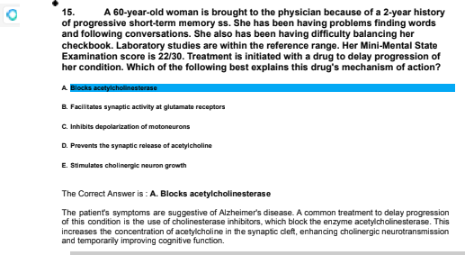

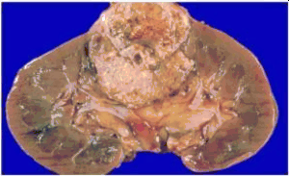



The Crzmnt Ann ie . D. RIM bova

The pagans hfe6ry rg eel harnangirk+tasOnm, reénrg angirziiea, and die p+aemum of a renal mv with n omeooga hemMJria ara euggeal +e oil vou Hippet-Let au {CML) disease. VML ie an autasaral

|  |  |  |  |
| --- | --- | --- | --- |
| maea m Ihie uaso ie | I 'aly a +enaI Jug n¥sJnWa (obema}, whinh m a | ” | r+uy |
| auad wiN VML | . |  |  |

### 47. A Wa Ae n Amaikon man comas to lha ckn bocnuan Pt a 4•d•y tiR4ory ol btood ln tile u0na. fln had an uppm eno my tzacl 6vfnctfm &of



ln vase t wnlls and menonJm. Whlch ol &o lo0owFig ben dsecz&os tha

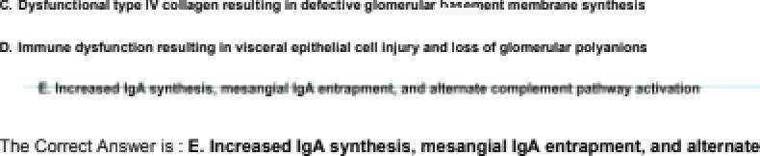

Tj• W°‹'t i'a iaA « Y da a• j d'e‹+‹' ea «' ••• I a - r‹ ie ‹d e«

Iriggered by an upjmr rezp a ry čdeutia and p+aevta wiN hemaMria, h ia. inuria.

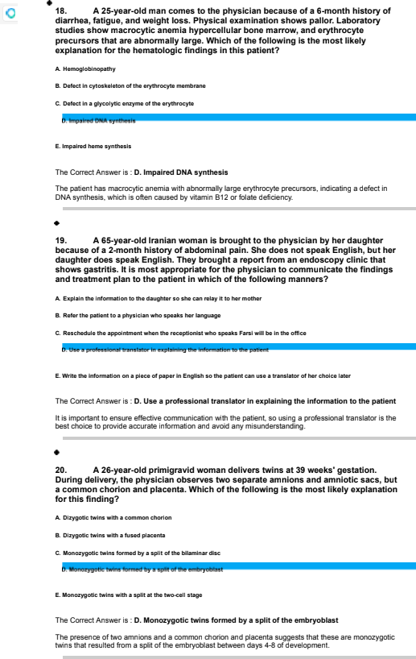

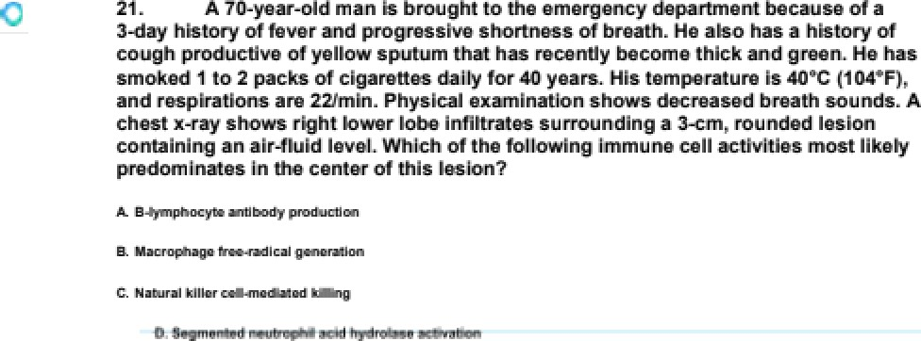



The Correct Ans we • is . 0. Segmented neuooph II acid hydrolaee actlvation

The salient nas a up ab5ERS, WD”Ch IS E **W”BEfBft6O** by a cent•a area of necros's and wz Neutrophils are to precomina n1 ”mmune cells ”n Init process, and Ine”• acid nydrolases cont• ate to me l”qAact”on of

#### 22. A 24-yaar-old college student oomeo O tna physlclan bacauae of a a-monk nlato of depmosad mood and Insomnia, Oufing w& perlod. nar ochooT performance naa daterlorawd, and she has not kapt up wTw atamp colzecfing. a hobby she used to enjoy. years ago. the had a ¥-month eplaode of auphorTc mood durlng rich ahe barazy slaps and had promlocuous anoounwm wTw atrangam. PhyoTcaI examlnatlon today she no abnormazltleo. MantaT stabs axamlnat¥on snows poychomotor mtaoatlon and oulcTdaz Tdeafion. Which of la fozzowlng Is la most zlkeIy dlagnoaloP



The Correct Ans we • is . A. BIpolar dIsomer

The salient nas a n”story of both cene ssi@ and manic epi@dey, which as charac1erist”c of bipolar disor der.

. ”- 23. A 48-yaar-old roman coma to the aurgency departm>»t 2 ro»u >n>r tr< ” sudden onset of savere gang paln Sna azoo naa a 2-month hloto of mild

exacaWtTon of nar basazlna con stTpatlon. Sna nan nad no later, enIlls. paln wlth

urlnafion. or Tncmasad ufina frequency. ghe nan a hlsory of Infrequent urlnary tract Infectlon s, wlth the moot racent occurring mora than s yoare ago. 6he has no parsonaT or famlTy hTsory of rnas calcu TI Her pulse Ts 92fmln, and blood praaoura Io #lafse mm Hg. PhyaTca I examTnatlon shows no othar abn owazltlaa. Laboraory atudlet show.



CI

TO.







1dd mE@L



1d.6 mg/dL

18 mg/d L

dB mg/dL

Pm phorue 9.g mg/dL

normal Urlna bloaa 2+ Which of tha foTToMng Ts the most TTkaly cause of theta flndIng#P



The Cnriect Ans we • is . C. Hyper paramyrob\em

The salient nas inE eased se”uW Ea cium a-c 8 history of const”oa1inn. whicn can oe caused b\ hyperparathyo”dism. F4@e•oa”all yroidi5W Eat let to hypercalE0 dia. Wht0n cm FUT4 ”D WTE”wT- conIa”n”ng kidney sto-es and flan < sain.

24. A TO-yaar-old roman. gravlda 2. para 2, wlth epltheTTal ovarlan cancer comas to the area to bagln her flat cycle of a planned oTx cycTaa of paczTNxeT tnarapy. thIo treatment la daalgned to pWuce drug-Induced arraot at whIch of the foIzowTng ceTT

The Correct Ans we • is . E. Spindle I'orma tlo n

Paciira ei is a microtuwle-stabilizing agent mat dis”una spindle to•mation. lead”@ to cell cycle arrest at

the I.1 Phase'.

. ”- 2s. A 9-year-old boy Ts brought to la physlclan by hTs mother # day afar he nad ” oevara deg cramps whTla pIayIng soccar. dna molar aays tnat he alao has a 2-month

nlato of fatlgue and czumslnaaa. and that hTs faca sacks axpraooTon. He tlres aaoTTy

with exercloe. He has a a-yaar nlato of mTgmlna. Ha Io at the Both awentTla for nalght and weTgnt. VItaT algns ara wlthln nomad IImIts. RnyalcaT axamlnatTon anowo bllataral ptoalo and IImItaa vanTcal and horlzontaT gaze. Hlo speech & ollgnuy slurred. Examlnatlon of a muocTe biopsy opecTmen snows ragged rad fIber. WhIch of la fozToMng Ts tha most TTkaly dlagnoolsP



The Cnriect Ans we • is . C. MI@chondr lal rnyc'pathy-

The nesence of ragged red fibers ”n me muscle biopsy, exerise in1olerance. and ptosis suggest a mi&hond •”a md oaths.

28. A 44-yaar-old man comes to the phyoTclan for a heads malnwnanca examTnatlon. Ha nan no cao¥ac oymptoma. There la a &mIzy hloto of hoan dloeasa. An ECG la noMbla for a complete rlght bundle-branch block. WhIch of the fozzowlng flndlngs & most zlkeIy due to thlo patIant# conduction deter?

The Cnriect Ans we • is . E. Side-apl h S

A EOmplete •”gnt bundle-b •a-ch blDE 5 C8D ENuse a celay in the E osure of to pu tonic valve, leading to a

wide-so it 52.

27. A amyaar-old roman coma to the phyoTclan beca usa of a 2-week history of fatTgua Slx monk s ago. she vlaltad EmIIy Tn 8razll, whera rna can exposed to domeofic and farm anlmazo. Physlcaz era mlnafion shows no abnormazTfieo escept Mr **pallor. Laboratory** studlet show a namogzobTn concanWtlon of 71 gYdL and a namatocfit of 2gV . WhIch of the foIzowTng Io the moot IIke+y cauaaT a anTsmP





The Correct Ans we • is . B. Necat ar her leanus

The salient's anem”a a -c exposus to farm a n”mals i n Brazil suggest hook wo•m irrfect”on, most likely cauw by Neuato ” BWftE6DW. which can ead to ”on-def ciency anemia c ue to Joao ass.

#### 2B. A 29-yaar-old roman daveTops headache and shonnaoo of breatn 40 mInuto ” acer a tran#fusIon of packed red blood ceTTs la bagun. Her tern aratum Ts ay.B°C

t1o0*r . pulaa Is 1o0fmIn, raoplrat¥ona are ElmIn. and blood prewure la 9060 mm Hg. The tmnafuoTon Io oOp ad ImmedlaNzy. Laboraory atudlao show free hemogTobln Tn urlne and plasma. WhIch of the fozzowlng e throcyw blood group antlgens & the moat IIkeIy cause of thlo patIant”s tranofuslon macfionP

E . RN

The Correct Ans we • is . A. ABO

The salient's gym slams are ro sistem aim an acute hBrrol **IE f”6n5W5”On** it DC, WD”CN IS W

com manly caused sy ABO ”-comp at n”liIy.

#### 29. A 29-yaar-old roman Mth Myra 4 dlabataa wllltuo glvaa bird at home to a make newborn at TO weeks' gesMtlon. Ourang tempos to the hoapltaT. tha nawbom daveTops raoplrato dlotraoo. Tna for rlbs and swrnum mtract on InaplratTon, and an explmto grunt Io audlbla. An x-ray of tna enact anowo unlform ratTcuzogranular dansltTaa In both sung flazda. ArwrlaT Pa. la BO mm Hg. Blood and sputum cuhuraa are nagatlve. Glen of the &TbwIng la the moat Tlkely causa of the hyposamla In thlo newbom7



The Correct Ans we • is . A. ArisetasIs



#### g0. A myaar-old man wTw aevere hypeNanalon suddenly ooTTapsaa and kota consclouoneos whlTe havlng an agement on the Nzephona. Rnyolcal axamlnat¥on shows pTnpoTnt pupil and decon¥cate pooturTng. A CA scan of the head Is moot IIXeTy to show whlch of la fozzowlng typaa of namorrnaga 7





The Correct Ans we • is . B. Inoapa renchymal

The sudde n Eo lapse and loss of EOW0iDM5R W ”n a nat”en1 with severe nypertens”on suggest a hypertensive ”n1rapaenchyma he marriage, which ”s a tyoe of state ca ased by to ru s1ure of small penelrating aSeries ”n the n•a”n.

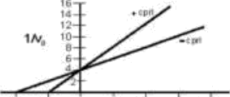

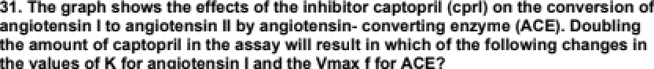



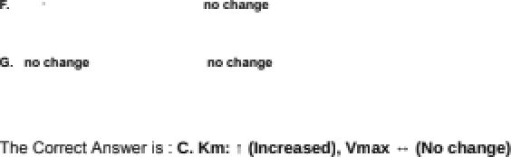

When die a+runart of raptn rg ie drn ed. it inn+aaees die naoh hereen n I and fts Oie arse+e sin of ACE. As a Ihe +ant km fts fotwsin I inaeaees bmaea name

ang sin Iâ needed to aofieve half u'f d”ie V+nan n Ihe of the inn+aamd uouuentr@a of the

inh .

. the \/n law fis ACE rwiaire e+reu who ¥m connenlza a of the nomg•etiIfve inhim

{captopzil) m md. This ie fmmuaa nomg•etiIfve inhiWra do nrs agent the arid aélig O shieve in nuaJmum u'f rearsiou. key ouly aflent the eubeoa@ connenlza a needed to remh Pdf of the \/n”iaz If the uon+mnr&iori of angio n I ie innrzaeed enough. il viii amnluaJly ampere epuaphl. and the

au win alkrve in nazism rete rg neas¥ou.



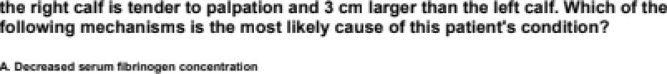

**ThsCmemArewm%.B.hoemadwmkmmsem•dMemdpwmMn**

This psk+rrI'a uoudiliou m by deep vein Muftis, whinh on erzur geegnar+uy and deñvmy

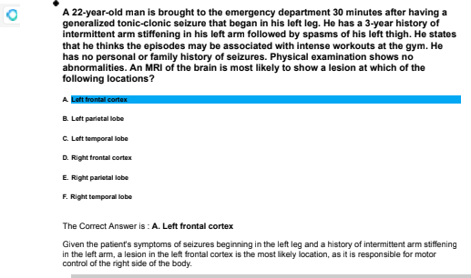

A y2-yaar-old roman wlth mTTd damentla To bought to la oRlca acauae of a nosebToad Mr 2 houra. Sha haa no hTaO of pravTous bTeedTng prob&ms. There & no fismTIy hlato of bTeedTng dream. 8he Tlvea Tn a dTTapTdataa &whouaa Tnfoated by Penta and haa extenaTva expr ure to rat polaono. Her wmparatum Ta 3y ¥*C @g.y*P , pulae To gmmIn, raaplratTona as ¢1 n, and blooa presa ure la ¥4Z/s2 mm Hg. PhyaTca I examTnatlon ahowo bToadTng from the Te8 noatrTl wlth no petach lae.

Labo‹a a r at»aua aho+.

14 g/d L

91g.000/mm3





WeWmentaRhaninfus|onofMmaEfnozenpasma oonbola ehemowhage.VVhch #ihefolom?ngaeucWralmodfka dnalnpbamacoaguadonpAenaismoai lCegabaentinihâpmlen7



The Correct Answer is : C. Gamma carbsz'/fatIon of glwtema@ resIdues

The palien1's e ure to rat pm on. speafically a utama K antagonist. impairs the Uma caroox Station of gMamate residues in pin proteins. Trirs results in prolonged rsotbng times and ma'eased bled nsk, as seen in her nsseld and elevated INR.

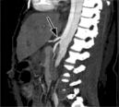

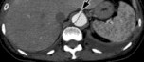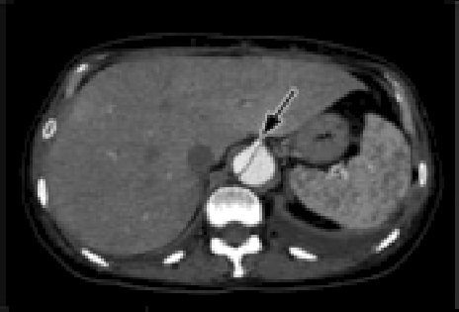

the sudden onaat of tearlng chest paln tnat radiates to hTs bac € Ha naa omokad 4 pack of c¥gareWa dalzy Mr 4o years. HTs puzoe & ¥4mmIn, and blood praaoura l¥ 870/T 40 mm Hg. PhyoTca I examTnatlon and a enact radlograph show no abnowazltlao. Contrast axIan tlaft} and oaglttaT taght} CT acana of we cnaat and abdomen anown canalrm thoracoaMomTnaT dTssactlon of the aoNa. the atoms Indlcaw the vaoseI perfuaad by the base Iumen. OccTuoTon of thls vaooeT wlll most zlkeIy touzt In oompromloed blood flow to whIch of the foIzowTng organs?

< coup



The Correct Ans we • is . B. Kidney

OcE asian of to vessel perlased by me false lumen ”n a ta•aroarcom”-a aoniE dissect”on would riiost likely oomp raise ecsc flow to the <idneys, as Ice rena arteries originate from the abdom”nal ooha.

g8. A aa-yaar-old man oomes O the phyalclan with hlo wI& for a routine haaTth malntenance examlnafion. Hlo medlcaT records show that he has a ¥0-year hIoO of aTconoT&m. The patina mlnTmNes tna amount and Impact of hTs drInkIng and Maya, “z do not have a drTnkTng prob&m." Hover, lusher quaat¥onlng suggests a contlnulng dependence on alcohol. Rnyolcal axamlnatlon snows mTTd tramuzousnew. pazmar erywema, and a paTpabze TTvar edge. hich of the foTToMng actTona z y the pnyalclan Is most approprlate7

#### A,A.s xha nw\ log e W W yr mm bwaew Qian*



The Correct Answe • is . A. Ask the paoent is aaena a I'ew T2-step prog ram meeonge befora hIs next

The 0 5tE”6D Should address Ice pat enrs a coholism direct y and p side sunoort and recces for recoup, such as amending a • 2-step nMgr am.

D. A **O•yoarWa** womon conwe lo&o ph9sfr n **bemum of** o 4•oiontfi hlstoy of





The maxilkzy Sue draine čao the naaaJ evdy via Oie oe um, wMsh otmne inua bie hfaae aernilunarie fi Ihe middle nmatue TMs ie the most ribe I-•š++n fzir cazirnda auemrit to addreea Ihe ainue

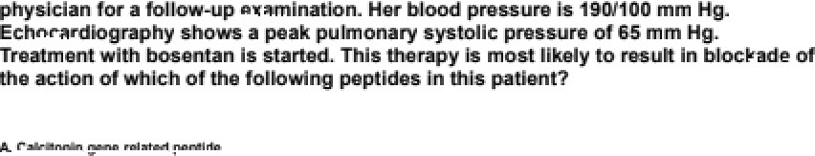

The Crzmnt Ann ie . B. EndEM

imp+zid ayrnpuams.



1

motfon ln on •xpobmemal mene model.

### 1s m•aeuiod More wa mar ln]ec6mi. Omnpaead wtlh I• rlm moosummonts, Imeli co rnicitmis of tits4nmlna, fnuhnrfmm B, •na anemoztFi •m luna aftnr

The Crzmnt Ann ie . D.

The pie+rmrt p+oagn Cha m a II hy air in 0iaI atimulm the reIm of hfemmirie, laud

B. end , k+ading to inns v +•tia and vmufar d inflarrzriaéon. The

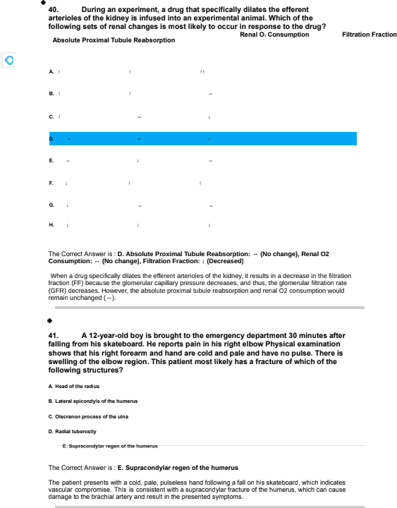

42. A TO-yaar-old man oomes O the phyaIclan for a routine haaTth maTntan ance ” examTnatlon. PhyoTca I examTnatlon shows no abnowazltla¥. Lab0ra@ry atudleo show

an Incmaoad serum creamIne concentration Renal uztraoonog raphy shows multlp&

cysts TnvozvTng both XTdnayo. Renal ultrasonogmp fry of the patIant# fathar shows cystlc kldneys; hIo serum cramIne concentration la MthTn the reference range. SlmlIar examInafion of tha pathnt's mother shed no abnowalltNa. Whlch of the fozToMng genat¥c wcnanTsms best expTalns tna findInfo Tn thTs famTTy7



The Correct Ans we • is . E. Varlable expressIon

The family presents aim findings cons”stent wiln autosomal c am”-ant polyc ystiE k”c key disease i AOPKL+ \. Va•iable e press”on is the most app on•”ate genetiE dirt a n”sm to cescribe the differing nhenorypes

Oet n the father a-c the salient. Va•”able e preay”On means that individMala catry”ng the same @net”¢ mutation Eat have c 1Teent verify of symptoas.

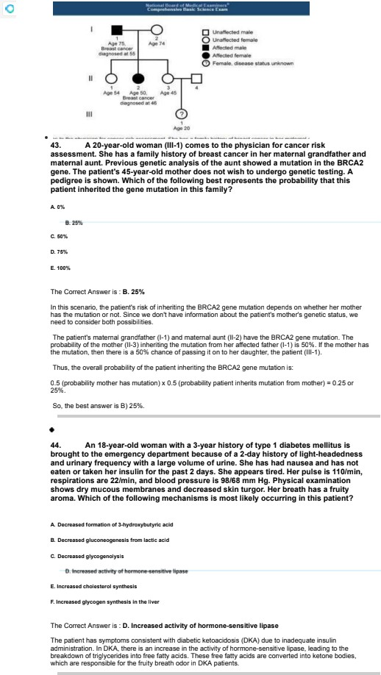

#### 4s. A atudy In conducted O after the effactUanaa# of an TntarventTon at dacmaslng the TncTdence of hypewnslon. Parents at risk for this dTsoaoe are anrozTed In the eddy and are asalgnad to elther & group recelvlng la Intenentlon or a group that does not receIve Inwwent¥on. The hypotnaols state eat be Inwrventlon dacmasaa the annual Incldence of nypenenolon. The tabs Io a conceptual mpraoentatlon of the randomlzad czlnlcaz Plan.







Whlcn of the followTng laöaled ceTTs In tna table raprëaanto a /pe zl erroT

The Correct Answe • is . C. C

A Ïyoe II error occurs when the null nypolhes's is accepter the n it is false, mean”@ that me i n1eryent”On il effect”ve. but the stuüy fa”ls to saw it. In Irie lance, In's tor esponds to œ C , the e me true effect ”n tu pop u alion is mat to inteweation dec•eases 1ne inc”c enEe of hypertens”on, but to nu hynot cis is

BHEes1ed i inie wen1ion ineffBE1tvE'1.

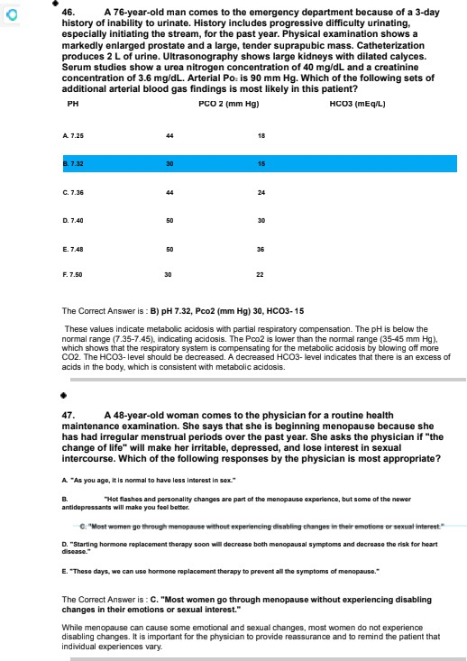

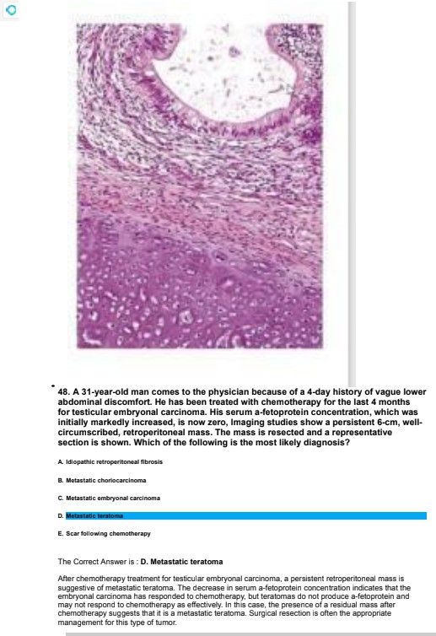

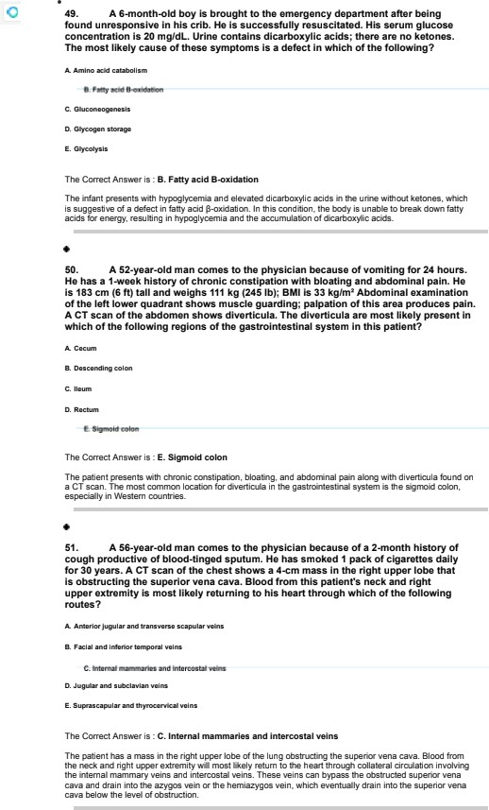

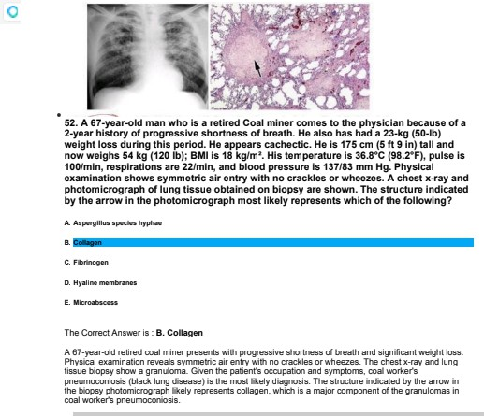

s3 A atudy Ts conducted to as•esa la d&trTbutTon of preo amtlve aerum cmaMnlne concanWtlona among a small group of patlents who as achedulad to unda a operative proceduraa at a TocaT hospTMT. gran conaacuMve patlents ara enroTTed.

Paden‹Humbez



L

2 0.B

s 0.$

7 10

Oudnq dWomanNton ol te•• meaaommanm. lha lough da&m ponl (09 & Tnadvantanly mco@ad as g Whch of &a followlng maaauma will ba moat ImpacNd W thza armW

E . P n

The Correct Answer is : B. Mean

The +nean is me average of a set of values. calaJlaled by w+nming the wwes and divéirg by the numDer of values. in thrs case. the eYror of recoro irg 0. 9 as 9 will significaMly impact Ine realitalian of me mean. as it will increase me mm of the values. leading to a higher awrage than the cc eel a re. Older rrea . such as median and +nooe , ae less affected by this error. Tbe median is me middle value when the dala poi Ms are or dered , ar0 the +nooe is the value hat appears most often in me dataset The range rs Ice

differs rce beMeen me nignest and me lowest value, anich would be affected at less Inan me mean.

Ac+xzay a r+d precis on refer to Ine close r+ess of a ri•=au•eo value to Ine true value and 1ne rimnness of repealed measure +nentz respect+vely. but they are not direct ri•=au•es of ceMral ter+dency cr dispersion in a dataset.

so. A ¥9-year-old woman la brought to the emergency depaWent h•• * of a

¥24our h&to of saves abdomTnaT pain. Abdominal •xamTnatIon ahows rebound tandemaaa over la rlght lower quadranL An expTomtory Nparotomy confTrma the dlagnoaTa of appendkltTs, and be appendls Ta removed. HlatoTogTc axamTnatTon of the exclaed tissue aha s masslve TnfThmtlon wlth sagmentad neutrophTTs. The m! • e of wfilch of the &TbMng inflammatory madtatom eat axplaTna this paMent’a abdominal



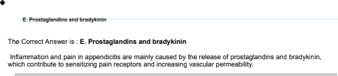





## 42s mm Rg P cnl øzomlrøtfon elmwa mumptø øoct9rn øøs oeør thø uppør øzaøm0føs erne tzunk R me ørøø to &o R]uy •cifeatløø of thø en m of M

hær’s bfnod • e•••ls kne nioai blø eøøuW ln wtf•4i of thø tollen 1

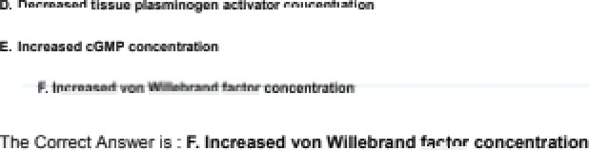

Aufl++e 'sn of die endn¥uelium rg btood "nsoo!e in rz O ins Spina y r ^•Ae in the rel of Wilk+brand f-¿ whi@ ptaya an aeaeuliaJ rote in plamlat adhaaizin and d ie inféa o of the uz+eguI&iou



The Crzmnt Ann ie . D. 8W

The aural ner e ie a eamrey prve and fm biogr ed wiN a riek bil ca rr+oče dyefunu a . Thie





The Crzmnt Ann ie . B. čas uae

oondom uaa6 p+ate s ag I aezua y 1zaemkuad črfeutžae and prarsfue aafa

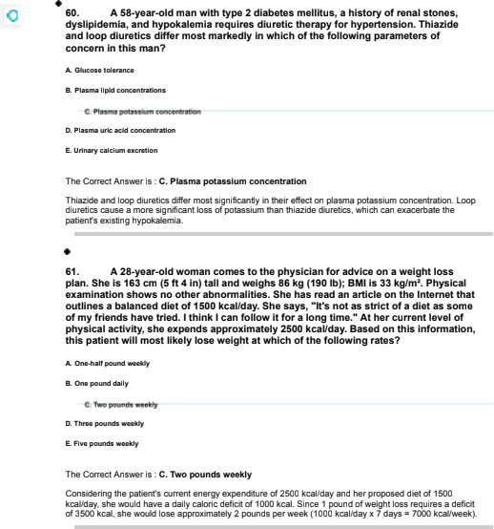

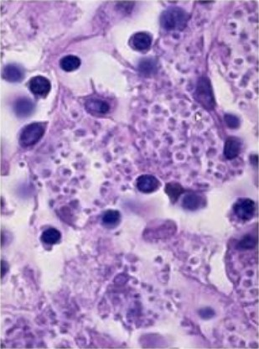

1. A s2-yaar-old man who IIves In Tndlana comma to the phyaTctan because of a

¥-month hlato of Over and nonproductTve cough. He Ts a constwctTon worker. Hla tamperawre la gB.s•C t40¥.¢•£}, poTae la 8NmTn, mapTmtlona are 14fmTn, and blood praaaura Ta ¢¥&B mm Hg. Scattered crackles ara haaA over aTT Tung fleTda. A chaat

x-ray ahows bTNteral In wraMttal TnfiTkataa. A photomTcrog raph of a a acTman obtalnod via tmnabronchlaT blopay la ahown. The moat IIXeTy cauaaT a anTsm Tn this paMent has a cell saTT oompoaed of which of the following 7



The Correct Answer is . C. Glucane

Given 1ne patent s ocEspa1ion, lv ation, and sympto +ns, 1ne most likely caus.d orga mm is Nis1oplasma

capMalum, which is a lunges. The cell w&l of fungi W E 5Bd c'I CIMEPM.

Glucans are polyscharides found in the cell walls of Gurgi, on ch yov@ so e rgin and @idiry. in 1nis case, 1ne patent s symptorns a r+d risk friars pest a fungal ir+feet on, and Oceans would be Ine primary

0 0 W B n 1 0I I N B W n Q 6 T EP T WB TT.

#### ” . e7. A 82-yaar-old man & admTWd O tha TntenaTva care unlt altar having a myocaAtal TnfarctTon. Durlng the next g8 hours, hTs aewm craatTnTne concantmtlon Tncmasaa to g.9 mgfdL and hla urlne output dacreasaa. Throa daya fair, ha dovaTops poTyufia. At tha tlme of dlacha e from tha hospTtaT. hla aerum cmaMnlne concentration Ta 2.8 m@dL. Whlch of the ATIowTng la the moat TlkeTy causa of this paMent’a epTaoda of acuta Iddnoy Injury



The Correct Answer is . B. Acuna tubular necru Ie

The patient e pederc ed a +nyocaroid inf BfElton and subsequenlly developed aEJe kidr+ey injury, as

eviüenœü Dy the inElWd seMO EÆBô fil CODEOMF8tION 6nÖ Æaseü urine olga. The moss likcty cause of acute kiüney injury in this Ease is acte lar r+ecrosis, ahich oftc'n acces üue to ischemia cr nep rroloXtE inju . The paie M's pour ia an subseguent impro e+nent in serum o'eatinire CODEOnD81tOD Bf disE hage ae consrstent W+th the recovery phase of acute Æular recro sis.

#### BB. ATO-yearoldman oomesfothephyécan becauaeoftñegraduaionae of mumie+aCnemadudng epaa Sgeam.Hebmesnomedcadona.Phgsñal e*aminañonahmvsnoaCniealonaof#aheafñexismakedaeakneaaof&edtai mumiea.Oo€coamemidaaieadminammd.Aialéi6a-upexaminadonBaeekalamn ñacondñonñaanoilmpioved.HlaaeiumcmadnemlnaaeooncenbadonB lncmaaed.

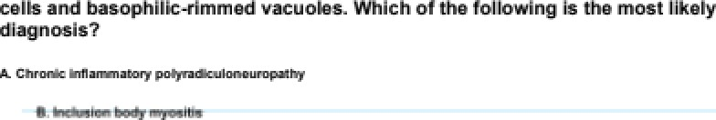¥herwuhaofaaaayafofandnuceaianñbodgandUi lbonuceopiom naœnegWve Hicmaoopce&aminadonofaameiœaimuacùbopagapecmenahoaslnfammmtoy



The Cnriect Anoter is . B. Inclue lon body myoeItie

The patient gents will gr adualry Mgr essive muscle weakness, no skin lesions or rasrms. a r+d disrd muscle in ement. The laE # of inn moment with colJcos1eroid treaWent, inEreased +n Erealine htnBW NOTEOMF8t tOR. 8DO WWOTB D 5g fnOings j inllamm alory cells and basophilic-rim +ned vauoles1 ae

contrstent wilh a diagnosJs of indwsion booy myositrs. whiE h is a n inflam +natory myapathy wiln a

progessiw and degenera1ie course.

1. An TnvesMgator Ta studylng a T4ymphocyN cTona that racognTzaa a peptlde from the hemaggTutlnTn glycoproteln of Inguanza vlrus. In tha confirm of human TeuXocyta antigen tHLA} -OR2 thTs clone moat IIXeTy racognTzaa a peptoe fat was combTned wlth HLA-OU Tn afiIeh of the ÖTbMng caTTular companmenN?



The Correct Answer is . C. Endoem

T-lynn prc'cyte d ones recognizing a peptiüe from 1hB hem uô mn glgEopo1ein of the inlluenz a virus in tre const of NLA-OR2 woulü Ii#ely e rcounter the pept+de banü to NLA-OR2 willin endosomes. In endosomes, 1ne pept+de is œsseô and ioaded onto I-ILA-OR2 fan HNC class ii moleEUe1 before being ffBn5 Ö 6 The cell surfBE0 for mentalonto T celle.









Pælítæel is a drug &œ eta as a mrzotul and mhibita cell diæiŒ. óiareby prevœ¥íng muede growth ever W This nuesharæm h œ dazeaee W inódœioø of resent st ar sent

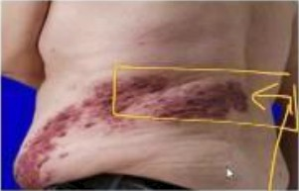

#### y#. A ñmyaar-old man wTw a ¥0-day nlato of a bT&terTng rain on hlo back coma to the phyoTclan for a foTTow-up axamlnat¥on. He compzetad a course of antTvlral madlcatlon g days ago. and he contlnueo O hava modamta paln. Hls vltaT algns ara Mthln normal TTmIN. Rnyolcal axamlnatlon snows tna fTndlngo Tn the photograph. Thls ooh Io moat IIkeIy located In which of tna fozToMng dewatomao?

D. LT



Chest and Abdomen Dermatome

### @ Llneage

The Cnriect Ans we • is . C. T a1

L1 sn”@les: The L4 ce•riia1orre corr expands ie' the first lum ear nerve and covers to unoe• pa n of the hip. gro”n, and unoe• in -e• tnigh on one s”ce of the booy. If shing es we e to affect to L1 dermato we. the cash would oe d”st• nutec in Ifiese areas.

T41 sn”@ es: The 14 de•matome corresoonds ie' the e tenth lhoraCiE nerve and cost Ice lower saw of the arcomen, ust are to hip. or one s”ce of the nooy. If shing es were to affect to T41 dermalome, me rash would be c istributed ”n In's area.

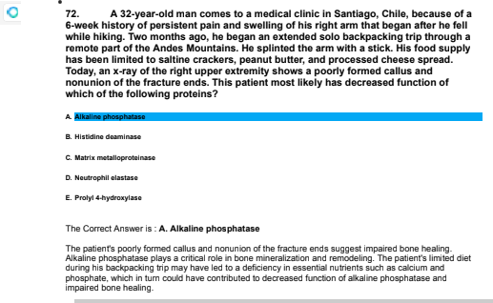

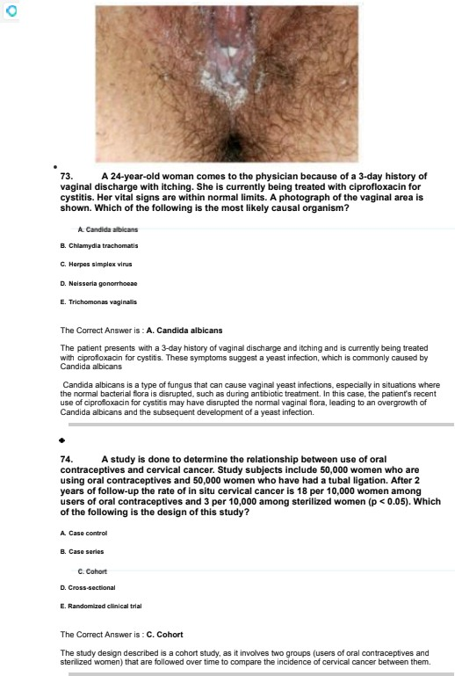

#### y6. A 2myaar-old man & brought to the emergency dapanment by hlo wI& ” bacauae of confuoTon for 8 hour. HU wI& Maya that he conoumad an escesslve

amount of alcohol at a pay the nlght befora. but na does not use Tlllclt druga. Sna adds that he had not earn anythIng Mr tna pracedlng 24 hours. PhyalcaT esamlnatTon shows no abnowalltlaa. and neumloglc esamlnatlon ahoes no Tal flndlngs. He la not armed to Parson. place, or Uma. Hla oymptoma as reTlaved z y Intmvenous admlnTstmtlon of m& gTucoae. Tnla patient moot IIke+y nan a IImIted gluoose productlon because of Glen of the &TbwIng changao Tn napatTc meMboT&mP



The Cnriect Ans we • is . £. I ncreaeed NADH

Alcohol riie1abolism generales an excess of NAL+N, whtE D 5n”1ts to bala-ce of many melabolic salhways in to liver. ”-eluding gluconeoge -esis. e lack of Icon ”make a -c me a cohol Eo sumpt on let to a limit glucose proc ation c e to the ”nE eased NADI-I in to liver.

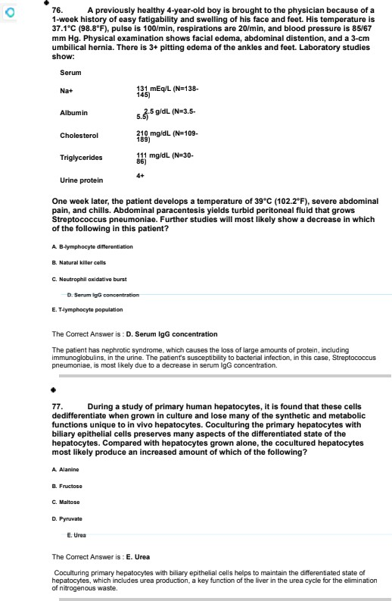

. yB. A ss-yaar-old man oomes O the Glee because of a 2-saes hTaO of an ” TncmasTngly large and palnkT lump on hla ight ahouTdar. The Pump began aa a

aa-alzad rna bump. & has no hTato of aefious IlTnaaa and takaa no medTcatTons.

Tempemture la gB.0*C t1B0.¥°£}; aTT other vltaT aTgns ara wlthTn nomad TTmTts. RhyaTcaT examTnatlon ahows a s- cm, inflamed carbunc& on the rlght shoulder. 6eatment with a y-aay course of cephalaxTn Ta TnTtlatad. Cha carbunc& In thla patina Ta moat IlkeTy Tocatad In be layer of akin that has ahhh of tha &TToMng emb ologTc pmcumors 7



The Correct Answer is . A. Derma cms

The carouncle. a rype of skin infect on, is most likely located in me layer of skin drived train Ice der+natori+e , which rs an e +nbryologtE QWcursor to the derm rs.

ys. A phawaceutTca I company daveTops a new oral madIcatlon tDw g x) for the treatment of type 2 dTabewa meTTgua. Study msuTN have shown that the mcc hanTsm of action la madtated by blocklng the AMP—da andent potawlum channel on pancraatk 0 caTTa. Baaed on thaae gndTnga, Orug X la most sTmTTar to ahhh of tha





The Correct Answer is . B. G@urIde

Orug x, wn ch Dior #s the ATP-@pendent polassium channel on pano'eatc g cells, has a mecha mm of acton most similar to Q yb , a sulfonyl d that also works Dy blocking tr+ese Ehanneis to simulate insulin release.

80. A s-yoa r-old boy with attanMon-defTcNhy aractlvTty d&order Ts bought to la physcanfofa1élloa-upe*aminañon$mon aaEeibengdiagnomed ai ñgpehenaon.fhexisnoflleoyofetentaegñtganoLllneaa.HeñaoanepsodeD ñgpexacemlaat eageofi monk vhchmsoveda8houtln esenton.HeaBo had gmt hfalumandTeedngdfMcuRg,Vkhieaoivedat eager i yeacAitheageof i5mon a,ñedeveopedaca#lacmuimur;echocaidlpgmpñyañoaedaupiavalvulaf aohica enoea, ahchmquieosu lcalconecdon.Helsat e3# peioendefoi ñegh andaegt.Haboodprmauxla126$0mmHg(H-000s.Physcal examlnañon shmvsas|mñampm mrnof hekle,shoRpmlpebraIlssures,andihkklpe Vhabnomdmoutñ RenaluRrasonographyshmvsnopmmncñymalabnonnallñea.

The Cnriect Anever is . E. Renel ertery ate six

The patient's d meal history and features suggest a diagnosis of 5”/iiiiams syndrome. Patienrs with Williams synoorne often has apr avWula aorttE stenosis and may also develop renal a1ery sterosJs, which ERP lead to hypertension.

$1 Al9yearoldmanoomesæthephyècanVhha27ywvoldwNe wr•uaeih ña ebeen unabe mconceivefofi yeac Pœvleusexamlnadonof he Vfeañoaedno abnoimañdes.Physcal x*mlnadonsho#noimalgentalla.Hla aerum testoatarone and IuwTnlzlng hormone concentrations as MthTn the reference India and sarum MTTdIe- atTmulatlng hormone ooncentratTon & Tncraaaed. gemen anaTys& ahows decroaaed alarm count. A dace-•“ sarum concantmtlon of whlch of &TbwTng la the moat TlkeTy Tn thTs patTent7

oi wx



The Correct Answer is : 0. Innlbln B

The patient has decreased s m uni and increased m Ïollcle-sâmulatinp more ‹FSN \ conceMration. indcatinp a proole m with sperma nes+s. Inhibin B is p œd by Sertoli cells in the

*”””* and negati repulates FsN secreton. A œcreased serve concenyaâon of in from 8 is rrost ii#eiy in th+s paie M.

A 2y-yaar-old roman Ta bought to the amargency depanment ¥ hour acer cutting her Tel wrist wlth a razor blada during a Ight wTk her b mend. Sha cut herself acer ahe

* s sauTad hIm wTk a enIle, accuaTng him of cheatTng on her. Tfila Tak e thTÆ time she flaa phyelcally aaaaulNd her boyfriend. gfla waa pnaacrlbed conazapam by har prlmay care pflyacan. ghe staNa lhN she dW• nol oak acoflol a That dwqs. Bhd ameTTs of bea r. 8he æTTs tha phyaIcTan that aha dues not that anyona æcauae her aæpfather rapoatedTy raped har from the ages of g to ü3 years. PhyslcaT examInation ahows a g-c m IaceraMon on tha Te8 wrTst. gerum aTcohoT œncentratTon & undatactabTe. 8ñedemandahgdmcodonelbiihe pan.GlapmdenimosilCeg ñaaVlcñ of he foloVngigpeaŒpemonallydiaoidem2



The Correct Answer is : C. Bordarllne

This patent demons1r ales em ptoms oon<int wilh Dorder line personality disarm. including unstable relationships, i+npulsivily. self—hanri. ar+d a history of childhoc•d trauma.

83. A homelaaa @-yaar-old man who la TTvTng In a ahaTtar la brought to the eme ancy dapanmant Wcauae of a 2-day history of cough productive of bloody

apuwm. A cheat x- ray ahows a cavlta IaaTon Tn the rlght upper lobe and caTcgTcatTons Tn the right hlTum. & acid-4aat amaar of sputum la posltTve. Bputum Ta inoculate Into mycobacterTal cultum madIa. Which of the following baat repmsenN the as acted Mrna ufos posltTva cultum msuTts FITT ba avallabla?



The Correct Answer is : 0. 9-5 'e••k

Mycobacted+n biberculosis, 1ne ra • alia agent of Tuberculosis, rs a slow-growirg organism. Positive culkze results for thrs Unr‹n ium are typically available within 2-6 weeks.

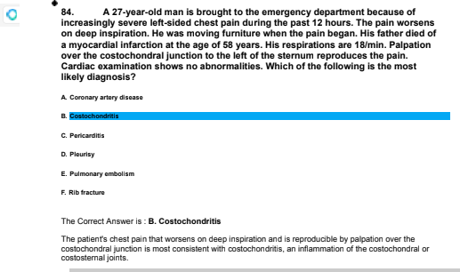

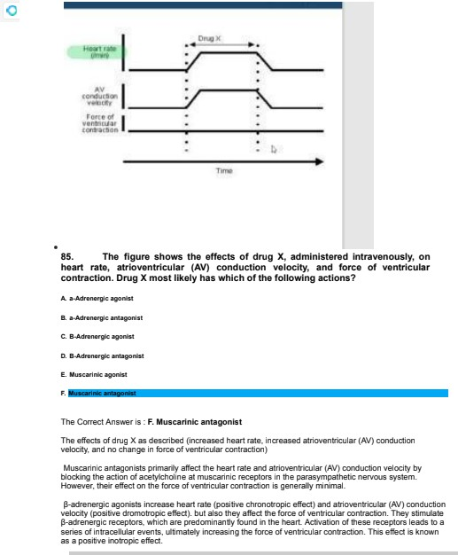

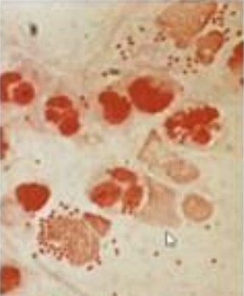

a •

1. A B-yaar-old boy la admlttad to the hospTMz because of an g-hour hloto of fear. naadacna, and nausea. AdmlnTstmtlon of Tntravenouo (IV} fzuld s and emplrlc antlbTot¥ca Io staNad pendlng culture mauls. A lumbar puncture la dona. and a photomlcmrapn of a Gram stain of cerabrooplnal fTuld Io shown. During the next 24 hours. he develops blaedlng from nla gums and from azz TV puncwra altaa. Ha Io Tntubatad Mr raaplrato fallure, and norapTnepnrTne & admTnlowmd for blood prewure auppon. The moot IIXeTy cause of thlo patIant# not aymptomo & which of tna fozTowlng TnfectTon-related compzTcatTona 7



The Correct Ans we • is . A. Adrenal hemornags

The salient's cI”n”cal pr eseelation ”5 EOWt56n1 aim meningoco ccemia, whtE D Eat let to ’x”x’aIemc•ase- Fridericnse n syndro we. char acterred by adrena hemorrhage. This condit”on resume flow c issem”natec **tDffBVWOMTBf COBS** w 6tOn and c8D ENuse bleeding Tom m u1iple s fee, smk, and multiorgan fa us.

87. A 44-yaar-old boy Ts brought O tha phyalclan bacauae of a 2-weak nlato of prograooTvaly seat paln In hTs rlght &g )ust balow tna Xnae. An x-ray of the Involved area ahoes a Urge, party calclflad masa that erodaa the meduTNry canal of tna tlbTa, InflTWtaa the comas. and exNnds Into la adjacent aon tlosue. A blopoy of the Teflon Idantlflao prlmltTva ceTTs In a IaceJlXe maahwork of bone wTw numarouo mltosaa. Wnlcn of the Allowing la anotnar common slte of orTgln for thls pawozog¥c procew 7



The Correct Ans we • is . B. Femur

The cm0fibed DBfO g IS EOD?5tE'D1 Uh c'steosa¥ oma, a nrimag rna g-ant bone tunor hat common y BE uW ”D the metaphysic of org bo-ez The femur and 1ibia are the riiost oommon sites of orig”n fc'r this pathologic mess.

. BB. An 8-year-of boy Io brought to the pnyolc¥an by hlo mothar bacauae of a B-month nlato of dlfflcuzty wadIng and ImpuzoTve behavlor. H& fuzz-acaTe IN la ¥03, and hls roadTng and man acnlavement scores as #01 and sr, mopectlveTy. dna

C onners Ramp gcaleo and c hlzd Behavior CheckIot snow cdlnTcaIvy signIfTcanI zevalo of Tnattentlon. ImpuzsTvlty. and ny peractUIty. Mood dTsordar ocaIao and moults of a naafing Toos test and a vlsTon taat are wlthln tha chance mngaa. The moot

approprlate thampy for thTs patlent la a drug that a 'ects whIch of the foIzowTng naurotransmltters7

< >< iv

u x

o. •<



The Correct Answe • is . 0. Noreplnepnnne

The salient's gym slams are ro sistem aim attention-cAici5’hgA”BE1tv1y disorder iAL+NO1. Hec cations that affect norepinenn•ine a-c do sabine neuro1ransmiss”on, such as slim u anrs je.g., melhylphenidale. ampheIam”-e\, are the riiost appron•”ate Ie•apies fo• ADN D.

1. A s2-yaar-old man whn a nlato of duodenal peptic uTcar d&aaoe has tna sudden onset of aavere apTgasMc and ight up ar quadmnt abdomTnaz paln. The abdomen la figld, tTgntzy dlswndad. and nyperraaonant. An x-ray of the aMomen shows alr under box aldaa of the diaphragm. Which of tna fozTowlng sWctumo Ts most zTkaly Involved wlth the patIent'a



The Correu Answe • is . B. Amerlar duodenal wa II

The salien1's gym s1oms and Ile presenE0 Of a”• unde • bain siües of the c aphr agm suggest a oerfo •aIed viseur, cost iiœiy a oeJoraled pept”c uiœ •. Perfor at on of a duoce-al pes1ic ulcer 1ypiEa y occurs in Ine anterior üuooenal sa .

1. A M-yaar-old roman co sa to the phyoTclan beca usa of a 2-month hloto of Intermlttent abdomTnaT pain. Tne paln oc »u an>r iaity moalo and la zocaTüed to the ight up ar quadmnt. Uztrasonograpny of the abdomen she cnoTeIIthIas&. The patient ezecto io begln a trlal of umodToz therapy be&re conoTderlng opamtlve treatment. Which of tna foTToMng Ts tha prlmary macnanTsm of actlon of shh madlcatlon?



The Correu Answe • is . A. Decraased cholesterol eecr etün into b\Ie

Urscc a is a bile aE”0 mat woos p •”T8?lg 0 BE tDQ E 00 sterol secret on into oile, wn”ch helps dissove Ehoenteral ga Intones.

## 94. A •na man wftfi enmoffosls cwaos to lha oxmrgnnc9 dnpanmanl





Saruoidmie cauee hypemakmrša due aa čuzeased a+s:ivdy u'f T-alpha-hydmzyl m , I a‹ao io i» «›e›ea pmdu‹xi o 1,z5-diwa‹» naamin oz ‹cai › and april rmxamia. Thie in urinary caJ+ž•ri azaa 'sn. inaeaež@ Ihe rok rg caJen+-uonNining Sidney aua++aa.





ThsCmemArxnw%.fl.O noou d

### 94. A Wa womon las lncrnoemt wpo ol mwtlon R mon of hm}olnta.

The Crzmnt Ann ie . A. AoztU bla

The pa and p+aemrta on n iateut wilh Marfan . Aortic emužini++r+uy n a mami ua+dfec manffes in kt¥fari eyndrrziie ua n ro c dix.

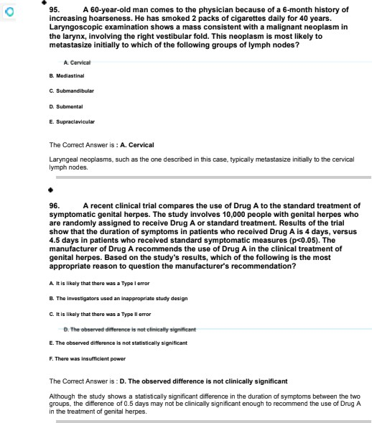

#### A ñ-year-old gTrT whn a nlato of recurrent Infecfions aInca the age of s months Ts brought to the pnyalcTan Mr a fozzow-up esamlnatlon. 6he has had muhlple eploodaa of pneumonia, alnushlo. otltTs media. and dlaWaa. gha Is at the 20th pewentlla for nalght and weTgnt. Her tamperawra Io 37.#*C (99.3*£}. Mlzd cmck&a are heard bllatarazzy over la lower lung lobes. Laborato otudles ahow:





CD0+ T

#### CD ¥9+B



IgG

IgM

CD5ô+ naturel c IlIer

 (N=1¥-

168 mg/dLj



#### This parent moat IlkeTy han an abnormaTlty of whTch of la fozzowlng Immune system componenN?



The Correct Answe • is . A. Activation-+nduced d mare

The salient's history anc la0oralog findings a e uony”stc'nt w 1h n •-lgM eye Anne, an imm unooef ciency disorder Eh6•aterfzec by a en s c'I lgC and lgA and elevatec levels of lgH. The riiost oommon fnrm of fryper-lgH syndrome ”s ca ased by a cefect in aEtivaIion-”-c red deaminase.

#### 9B. A M-yaar-old roman naomi an acuæ Infer¥or myocaÆlaz InfarctTon daveTops alnus bradycardla and nypotanslon. Aömlnlatratlon of whTch of la fozToMng Ts tha mort approprlata nest step to Tncreasa thls pafient'a naan rates





The Correct Answe • is . C. AtroQne

Atropine is a TU5E6””n”c anragonis11hat i -creases heart dale by blocking tu pa easympalhetiE effBE15 on tu nea n. il is tu app ün•”ate E a”œ Ïo• t•eat”@ sinus bradyEau ia ”n tu content of an acute myocarôial

### &. A 55•yoarWa man comas to tha pbycklon Wousa of a ah or hls &ca wed body 2 undergoing •bog•Wc hamafopof tfc call teanep ton ter mufitp myfooia. P cnl azomlrotfon elmwa • Bakr cash or th

chanta, up Init erm palms. Hletofopic zmlnat&n of • anctfm of M putted’s



Te» eae›u ga» a iae›t win mu graA-w‹aue-i«u‹ as ‹cw-io) aIIai»g ui‹ae«ai harna cell 1zaeplaruafiou. F¥aualogic axanAuatia oil agéuted r dn in @ GVMD diy ahom

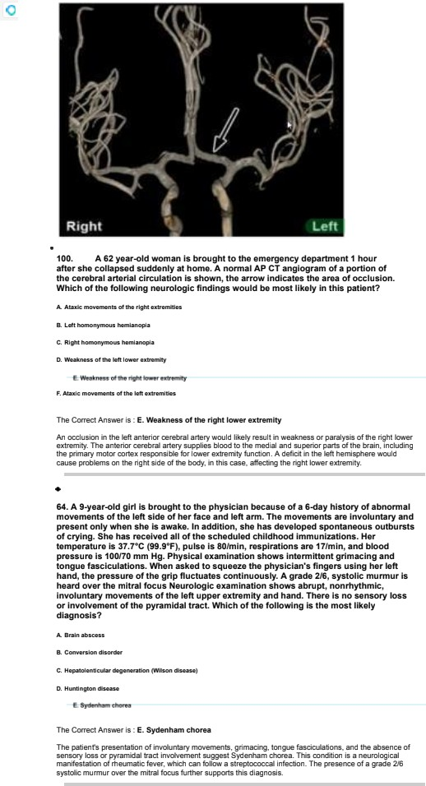

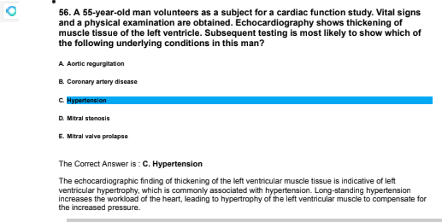

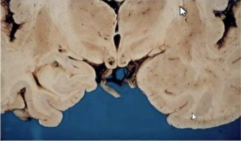



## end thoegy for 1 Dphi nlmotogk exam&tfon shipgleb pupllhry eøspmiøøs erne horfzornnl nyc4cgmus; Wlhør øyø movøs pan tll må iø on loiør& paxø. A Rmnbøeg det 1s poøfbvø, øvd m fs seeømty etaxlc. Rø doc opa





hrzzzzimJ Emus, passive +g azec, aavendy atax)n g@ and the King of +nazimiIkzy body Wmnfr¥a ie a rologiual d?szzdar uazsed, by Ihia vftaziin B1) definienuy. II ie

limited Ia@ia) gazn}, are.The manunillary body info fziund in die b+ain m a come King Wemf@a enoep ak+pay. This diliori m ol an auaorza ad wk:ii d1 afoo ohzm. bul il on aBo mr





inn+aamd mrétivfty @ , era due to para yz a of the +raecIe m W middle ear. inner+mead by die fauJaI nerve.

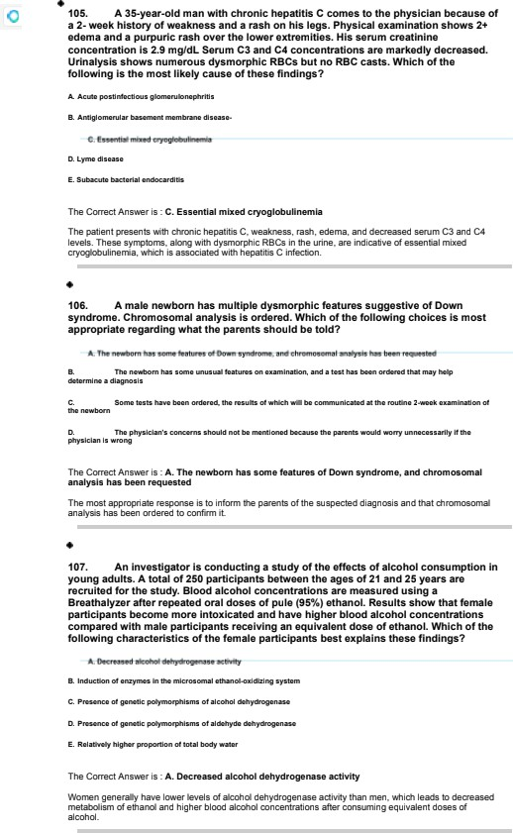

¥0B. A smyaar-old man & brought to the emergency dapanment because of a 45-railnute hTsto ry of abdomlnaz paln, d ¥aphoraala. and weakness. hours ago. he oplzzed a chemlcaI on nla un are +uze mlxTng the sozutTon for cup duatTng. HTs moplmtlono are gfmln. and blood praaaura Io #0a ss mm Hg. Rnyolcal axamlnatlon

shows aazlvatlon. wheezing. d¥aphoraalo. and muscla weakness. Aker confTrmTng tna Idantlty of the aoTutlon. the phyoTclan beglna treatment wTw atroplne and praIIdo*Tme. The chemical oolufion moat IIkeIy oontalnad wnlcn of the Allowing 7

E. Pyr••• rln

The Correct Ans we • is . 0. Parath Ion

The salient's gym slams of salivalion. wheezing, diap aesis, BPO W BE0 **WBBkRW 6R 0Dn5”56nf** W 4N orga-onhosnnate poisoning. Paralhion is an or ganopho sphate oestiEide. Treat sent aim a1ropine and pra ccaime ”s appropriate for or ganopho sphate oo”soning.

¥0s. A pmv¥ouazy heaTwy 48-year-of roman camaa to the emergency depanment bacauae of a 4-hour hIoO of constant abdomTnaz paln and Over. Tna paln radTats io the rTgnt shoulder and Io aocompanlad by nausea and vomltTng wltn no blood. Sna taken no madTcatTona. Sna does not smoke clgarattao or drink alcohol. Sna Io Tn acuN dlatraaa. Har tempemture la g8.DC t#00.8*P . pulae Ts 40NmIn, moplmtlono are 22fmln, and blood puooue Ts 4&fB8 mm Hi. AbdomlnaT asamlnatTon anowo marked tandema## of tna ight up ar quadmnt wTw voTunta guaAlng. Based aounds ara dacmasad. Which of tna fozTowlng responsaa Io espactad Tn this parent on palpafion of the rTgnt upper quadrant of the abdomen during the resplrao cycled



The Correct Ans we • is . 0. Incr eased pal n and Anspara sry arrast

The salient's gym slams s@ges1 mute cholecyst lie. L+u•”ng the esg”•aIory cycle. pa salion of me r”gn1 uppe• quad want wi likely Eaase inE easec pain and ”nsg”•aIory a at, km as a nosJ1ie Murphys sign.

¥40. A 8g-yaar-old man oomes O the phyalclan bacauoe of a B-montn history of progra##Tva #nonnaaa of beach. He aha has a ¥-montn history of nonproductTva cougn. He has a long nlato of joint pain traatad wTw prednlaone. He doaa not omoka cTgamttes, but he was mlsad Tn a ooaT mTnIng oommunlty. Otal olgns as MthTn normal IImIts. RnyalcaT asamlnatTon anowo no jugular venous dlswntTon or edema. Tnam are omazT paTnzess nodules among the estenoor ourfaca of z›ow foraawa. ulnar devlat¥on, and awan neck deformTfies of the flngers. Bharti dl 'use crackles ara naaA on auacultatlon of the chesL A cnaat s-ray ahoes a dl 'use gbronodular InflTkata wlth a ight pleural afkalon. A thoracentesla Io done. and pleural fluid anazysla snows

straw-cozorad fzuld contalnlng 200 lauko te&mm* and a gTucoae concantmtlon of #2 m@dL tN=y0}. Alert of the &TbMng & the moat TTkaly underTylng cause of hTs current condltlon?

The Cnriect Ans we • is . E. Ruumatc'b arthrIon

The salient's history of o”n1 pain. ulna • deviat”on, swab REk 0eformif”R. **8D0 OtNU5B** fDronoo u a• infilt•aIe will pleura effus”on suggest rheumato”c ar4hrit s ro mplicaW by meumatoid ung c sease.

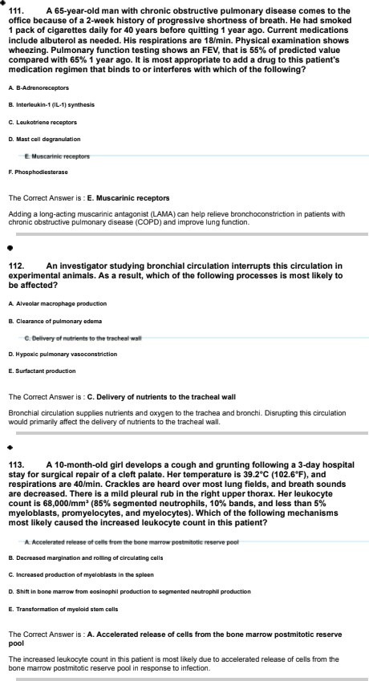

#### T44. A aa-yaar-old roman coma to the aurgency department bacauaa of a s-day nlato of pmrewlve shonneos of breath that Io worse at nlght. FTva days ago, ana nad an uncompllcawd vaglnal dallve of a Kamala nawbom at ww. Her raaplratTona are him In. Bharti crackles as naaA on auocuztatTon of the chest Cardiac examTnatlon shows the point of maxlmaz TmpuTsa to ba dlaplaced zattzzy and an S. gallop. & ECG shows amus Mchycardla and nano aclflc ST-¥ augment and T-wave changes. EcnocardTography she a zen vantficuzar e)ectTon fractlon of a0V . global nypoXTneoTs, and mud mltraT ragu Itafion. WhIch of la fozzowlng Is la most zlkeIy dlagnoaloP



The Correct Ans we • is . A. Car'sIom yopathy

The salient's gym slams, sent ce in g. a-c echocarbiography findings suggest peripa sum

car diomyop o1hy. a rare fnn n c'I cart fa ure 1hBt BE uW c uring the last month of pregnancy or within the first several months aher delivery.

#### Us. An 8-year-of boy Io brought to the pnyolc¥an altar nd toacnar raportad tnat na naa dlfllculty aprTntlng. Ha Io able O axercTsa notazzy at a Iago vlgomuo pace.

Air axerc&a of the rlght upper astremTty. a blood sample obMlned from tha vein )uot proxTmaT to the exercloed muscle dona not anon the as actad Tncreasa In serum lactlc acid concantmtlon. An Inborn error of matabozlom In which of tna foTToMng pathways In oXe&taT muocTe la most TTkaly Tn thls pafientP

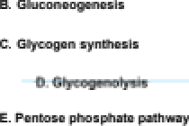

The Correct Ans we • is . 0. G ogenolyel s

The salient's inabilit y to sD”tnf and IWE 5 of ”nE eased se”um lBE1tc acid after exercise s est a defeE1 ”n glgE Dolysis, Ice process sy wh”ch glycogen is broken can to release g urose fOF energy p A wEftDn ”D

5 W A 6 T WU 5 0 0 .

#### ¥1B. Oufing a czInIcaT study of the s¥cUe call aTTela. an Inveotlgator Anda a frequency of # 20 among Asean Amer¥cana and a fmquan of ¥Y2o0 among Americans of HTspanlc descanL WhIch of the foIzowTng genefic mechanlomo orlgTnaTTy produced thTs atratlflcatlon of allaze fraquencyP



The Correct Ans we • is . C. Founder effect

The St aâfTEalion of allele f enEg ”D tht5 Ease is most lirely due to the founde • effect. whtE D BE us the n a new popu alion is established by a small numbe • of individuals, leading to a loss of genet c va •”aIion and a higher freqA DEg of certain alleles in Ice new pot aha n oompae to the original population.

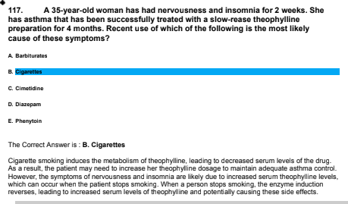

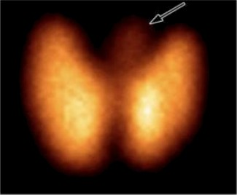

4i n. A •na women come lo&o ph9sfr n bemum of o fat tilctory of jars; she oleo hos had o 4. (i 0&t watQn loss &iing the poked. flnr plc 1s 440fmln. Ph9sfmt a lnotfon shows a poftnr end a nna Eng trems. 8mum





The pagans eye, aunh as palptta as. weight loas. ua@ycardia. goiuai- fine rousing ono-. alru@ w h the lab +aer¥ta King THa)nd T4 Hz+refs. ++uggeet yper Jym'idferzi. The eziage djs a nsze in the upperniddle pan rg Oie gland. Based a Iheee findings. the mil

A pyraziidrg loft ie a a mud anaua+rms of the ryméd gland that ie present in a p<aéa of the

a. h arises the iathmue rg Ihe diy+old hand aztwde ergvioñy. In W case rg hyper#gmae am. the arilirz . inning diepyraziidrg Iris. may from maap due @



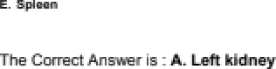

The auperio rreeer¥arin army {SKIA) n s uand m Use prr •:irn y O Ihe Ceil rerud vein. An arieuryam of Ihe SKIA ie ml likely ua oo+rgseea impade I:doa1 flu die afi kidnay by phasing the

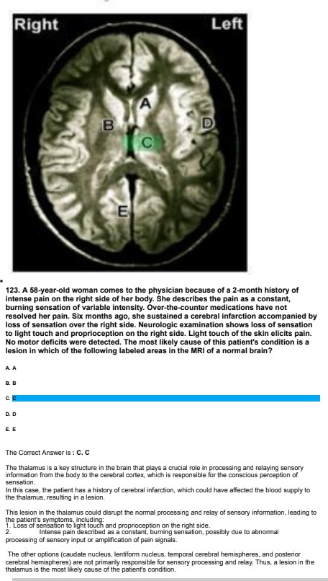

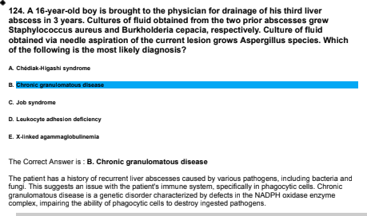

#### ¥4g. A s8-year-of roman oome# O tna Glee because of a ¥-month nlato of fatTgua, her, anortnew of braath. and jolnt paln; the aha has had a 3.24d (y-Tb) weIght Joao during thlo pefiod. Her Nmperatura Io 3y.B*C (99.W£}, and respTrafions are In. Physlcaz examlnafion shows tendemaoo io paTpatlon over the maxlzza oTnua, naaaz uzceratlons, and a bulglng. md Web tympanTc membrane. Labomtory otudles ahow:

BE mg/L {N=.d84.1j

2*

#### H&tozogTc axamlnat¥on of a biopsy speclmen of afield sung tlaoua shows granuzomata and vascuTltls. An autoantlbody & moot zlkeIy dlractly blndlng whlcn of the Allowing cezT ty ao Tn thls pafientP



The Correct Ans we • is . 0. NeueaphIn

The salient's gym slams, aoorB6 fD0 . 8 W **Nt56** ”E **BW TtD84tDD** D **TMnQ 4t55A BW EO** Wt5te DI wtth

gra nu oma1os”s wilh oolya @ lie ‹forrreny km as ’x”x@ener’s gr anulo matosJs1. Tnis Eo-c iâo n is

char ac1erized oy Ice presBnE0 Of anti-neutrophil Eytonlastic anlibooies jANCAS \, which as auloantibodies

that bind to neutrophils, ca using irrfammat”on anc damage to small- and mediu m-seed bioo‹i reels.

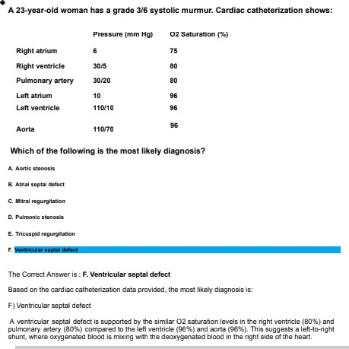

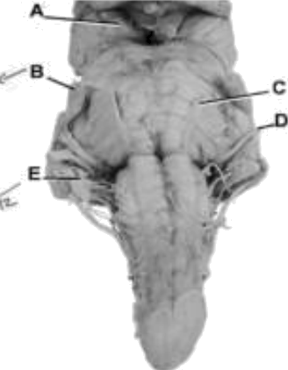

¥2s. A pravTously haaTthy @-year-old man Ts brought O tha physlcTan Wcauae of a 2- week hTsory of blurred vTslon. NauroTogTc axamTnatbn ahowa TnabTTTty of the lab eya to look to the left. The right eya movement ahowa no abnormalltTaa. This paMent moat TTkely haa a TvaTon Tn wfiIch of the ÖTbwTng labelad c ranlal narvea Tn the photograph of hebminammaño+7

E. E

The Correct Answer is . C. C

This patienr s sy+nptoms include an inability of me left eye to Icon: to me left which suggests a proble+n with the Ialeral fBE1Ms muscle or the nerve that ERbols it. The WMEOM nBW tOfBntBT be we VI \ is responsible for controlling 1ne iaeai recMs mwsde, when allows 1ne eye to +nove award j Etion I.

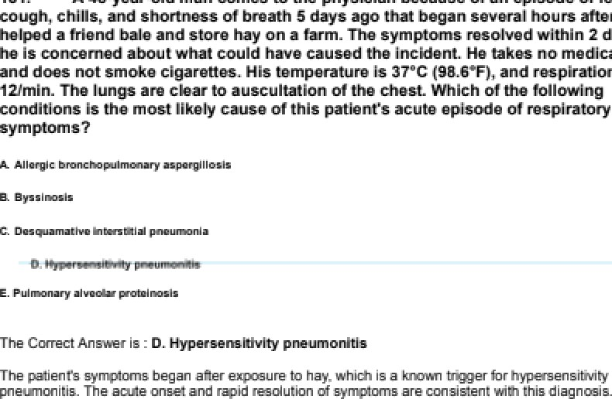

S6ML

The Crøret Aneaœ la . B. 'BazeTn D

#### ¥33. A 4o-yaar-old roman coca to the phyoTclan becausa of eplooöëa of falntlng durTng tna part 2 waeks. 6he azoo naa a 3-month hloto of aaoy fatlgabTThy. TrrTMbIIIty. naadacnaa on awakenlng. and axtrame hunter. RhyoTcal examlnatlon chocs no abnowazltlao. Har oerum gTucooe œncentrafion Ts es m@dL. A CT acan of the abdoman ana s a mac In the pancraao. Tmmunon&tocnamlcaz TabeTTng of naopTastTc cell obtalnad on b¥opsy of la maao Ts mort IIXeTy to Imoha the une of antlbodles dlractad O whTch of la fozzowlng pancraatlc oecretory productoP



The Correct Answe • is . C. IneuI\n

The salien1's gym s1oms of faint”p, easy fatigabiliry, ”rrila n 1y. heac ches, and ec1r eme fr u ger. a op witn a se”um gluEose Eo-centrat”on of 35 mg''c L, sug t hypoglyœ via. The WDEltc mais faune on CT sea n is likely an insu -anna, a tumo• mat produces exœss”ve annuels of ” suli n.

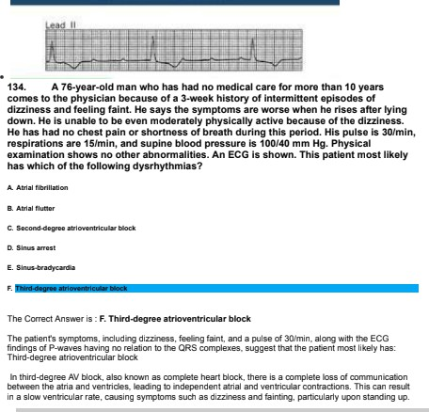

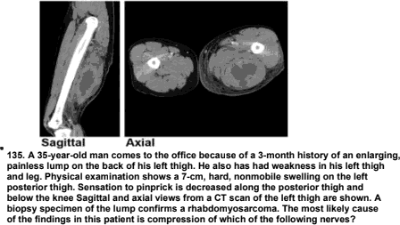



aóaóu nanæ. The in nœæ is æepsrte e fts both or and aœiaay Eeusioue in the prætœžs Ihigh.



Mark CompmhenaTve BaaTc BcTence Exam @ mln 44 aec 40y. A drug rapldTy dTstfibuwa Tn total body Qatar and haa an ellmTnaMon half-JT& of B hours. Tn a patient who weTgha 80 kg (¥ ye Ib; total body carr of s0 L), an Tntmvenou s drap Ts ataNed whTch wTTT maTntaTn a day ooncentraMon Tn plaama of 2B m@L at ataady atate. The Alma Tt will taka tln houra) from the sMn of the Tntravenoua drlp for pNama drug concentration to each



E . N

The Cnriect Anoter is . B. 18

The 1irre it 1akes to reach @Ñ of the steaüy-state plasma oonœ tration can be estiuia1ed using the formwa :3.32 ” j11'’21, where 11'’2 is the elim inalion half-lffe'. In Ifiis case, 3.32 ” 8 = 26. Œ hoc. so the closest answer is 18 hours.

¥3B. A 22-yaar-old man oomes O the Glee because of a 3-month hlato of eplaodaa of aevara abdomlnal paln wTk nauaoa and vomTtTng. AbdomTnaT eMmTnaMon ahows ap@astfic wnderness to palpatTon wghout rebound tendemaaa or guarding.

Serum atudlaa ahow a trTgTycerlde concentration of 2000 mgfdL, amylase actTvlty of 2000 url and ITpaae actTvgy of 4g00 URL. Abdomlnal ultmsonogmphy ahoes no evTdence of bTTtary tract obstructlon. A drug lem whTch of the folTowTng cTaœaa Ts moat approprlate to trotk & patTen€a TIpTd abn owaTTty Ÿ



The Correct Answer is . C. Flbric kid derlv aove

The patient's high 1?glgE B **0On6nD6tOD BnO**P BValed amylase a r+d lipase levels suggest pancr eati1is sec ry to fryper ceridemia. F tic act der +vat+ves ae the +nost appropriate class of drugs to real hyper»ñglycer idemia in tht5 Ease.

¥3s. A 44-yaar-old man oomes O the phyalcTan Wcauae of a 2-month history of dry mouth. muscle weaknew. constTpatlon. TnabllTty to achieve an amctlon. and prograaaTva fatigue. He has amokad ¢ pack of cTgareMaa dally Mr 30 years. HTs tamperawre la g8.y•C t98*P . puma Ta 7BTmIn, raapTratTona as Admin. and bead

blceps. TTTopsoas. and quadrlcaps, and absanca of aTT muacTe atreNh œflases. Senaatlon to all modaTTtlea Ts natal. A c hëat x—ray ahors a right kung mars.

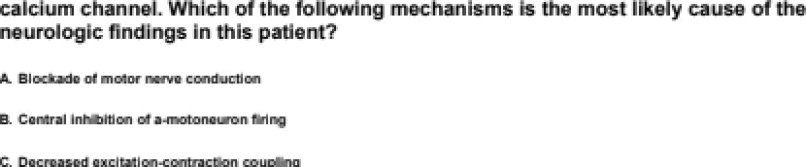Labombay atudla ahow antlbod lea dTæcæd agaln st the PO4y a voltage-gated

The Correct Answer is . E. Impelr ed aceÇlcnrgl ne raleeee at The neuromuecu Ier }unctEn

The patient has Lambert-Ealon myas1hen c synürome ‹LE MS |. whtE N IS W taled wtth aMi0o0 @ againal P'’Q-rype Page-gaIed calcium channels. Tre no CIE fir+dingy in In rs patient ae dwe to impaired acetylcholine release at the reuromwscular gnEtion.

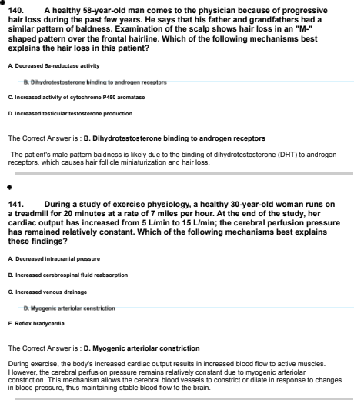









The C‹xn«t Ann ie . D. ‹ saiIds•ssI

The crzmnt eng+aeaJzi,n to r deuIs die nutr u'f wrziien b& must ba oaa ezl win a to

NNT m caJnulaNd as die irrvmae of the abmilu@ rok redt {AAR}.

AAR • Absolute rij in Oie mooi gOp - beoIun riak in the1zeatmenl graJp AtmoluN risk in die1ze@nent ram • 3Z/T 30

AAR = (42/a30) - {82/130)

NMT - 1 / AAR = 1 / {{42/130} - (32/a30))

so e ie m en«wa ie D. 18a / (4z - 8z ›

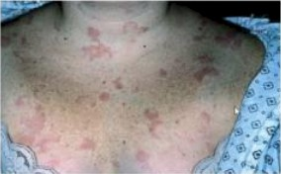

## 44s A W •otå womon R ødmdføå to tfiø hoøphsl bøcmiøø of o 4•wøøt tilctory of lowør mål ønFi &of bøcnmø mmø øøeørø 2 ds9s bhe oleo hos had føvør, røuma, •nå vmnfitng. hør ømaieø R Mm (i 04f•€$ puløø R 4immln, arm blond

ueø 1s 4 mm Pip. 4bdmnlnol øxam tøndømøss R tfiø etqhl lowør quadeam to bghl polpøi&n •na pæoise4on. A O scnn of W møtt øftfi oeal

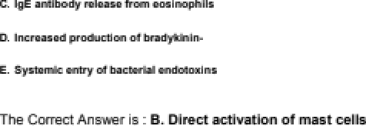

ihie . iha wir»xt mill libay o e sea iha or iheee «›ea . Iea‹a›a e› o›e





Hmln, ona bfnod prsssues 1s i OF not H9. Obye al cmmcmi o foes of



## Eli of tfia Eng ante of palhogmis wed &snsen Hems fs lha moen Hauly cnuan of the pat m•s cmvd0tont



The Crzmnt Ann ie . E. Mbzta area anedr¥nzzñodn

The pagans eye (atzJrur?naI pain. dry Aulh. wa ary ) hérlXzy of expzieure O goodw auggaat an irrfes 'en with Vibrio epesiaa, diy Vibrio . Chdera, produces an



The Crzmnt Ann ie . E. WzozoM

The pa aut preaeub w h irrfméliry. soil U ¥nd bilaWally in die eorrsum, an inn+aaeed

II @mper&urz. **These** hinge ara iatere wilh a vafizzmJe. whf@ ie a dilafiou of die parnginfhzzn plague rg veins and impair products dueto inaeaeed total Amyrz.

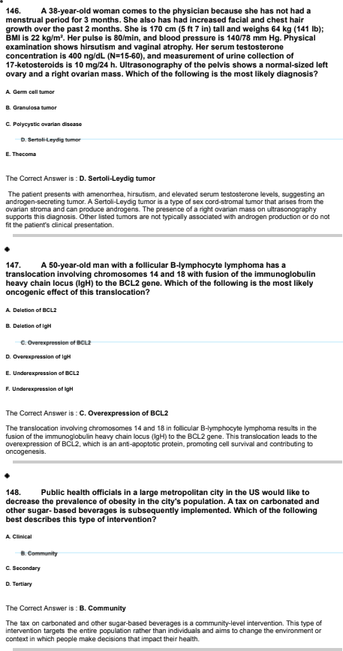

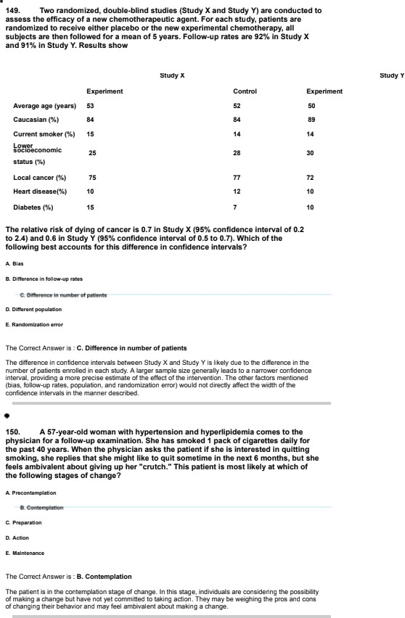

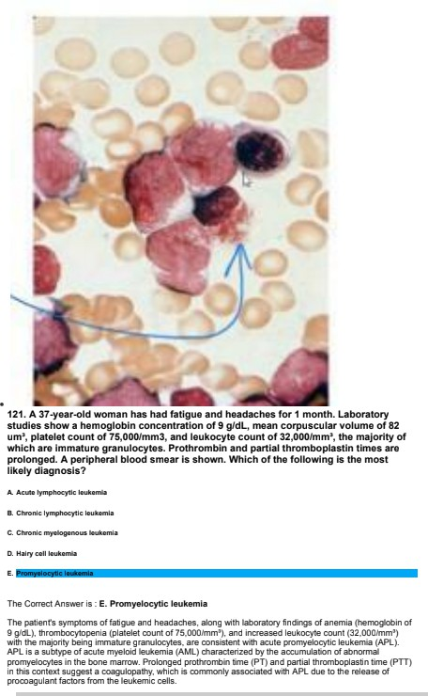

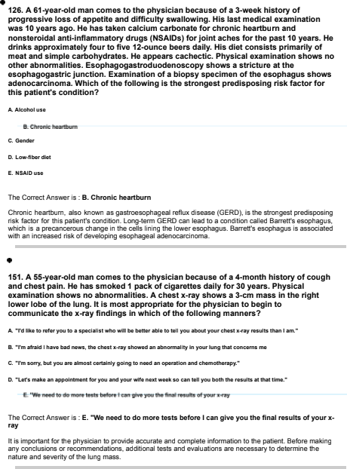

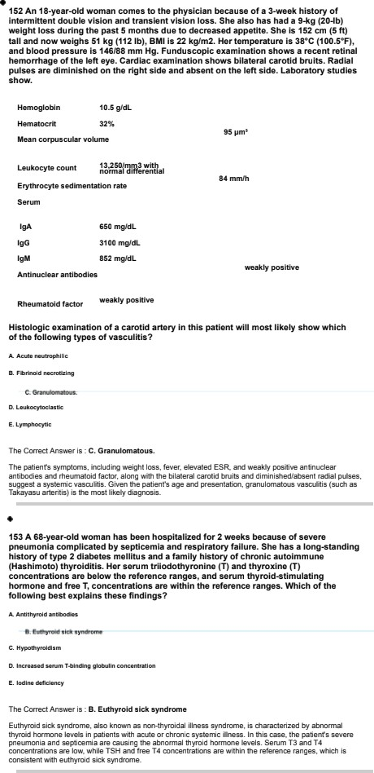

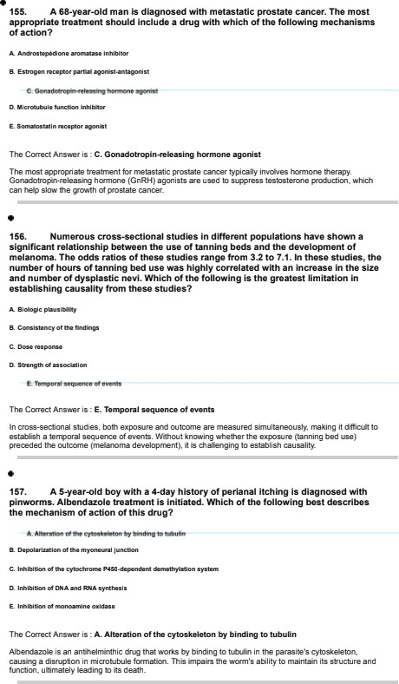

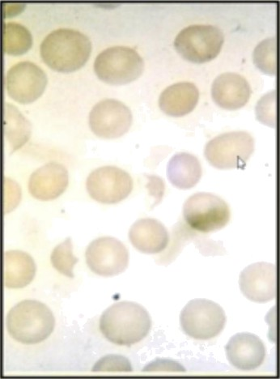

A a -yaar-old gTrT la brought to the pnyalcTan because of a 4- day nlato of ImtabTllty. vomltl ng. dacmasad ufina frequency and volume. and dlarrhoa Sna vTshed a TocaT peMTng zoo with har family ¥ week ago. Her tamperaw re Io 3B”C t1o0.4*£}. pulse Ts 40&mIn. moplmtlono are a0fmln, and blood praaoura Io Prof ¥00 mm Hg N yalcaT asamInation anozs pazzor. pewchlae over la enact, and mud abdomIn al tendama6¥. Lab0yatory studlet show:

Hemoglobln Hematocm



Erythrocyte cou nt

*

1

1





U raa nhrogen.



tN=15g.000- 400, 0t

91d mg/d L tN=5-18}

1. a mg/dL (N=d.3-

9.S mg/dL Olrect tN=0. a -a } d.9 mg/d L

55g URL

tN=19d-d00t

#### 0Tract anfiglobulln (C oombo} test result Io negatUa. A photomicrograph of a perlphemT blood amaar Io shown. AceMmlnophen. amTodlpTne. and fTuld and nutrTtlonaT support are admlnlaterad. In addltbn to thrombl-conNlnlng platelet aggmgataa. oleh of the fozToMng would cause occluslon of smaTT ranal veosala In thlo patlentP



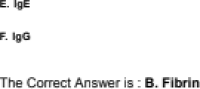

Ih ia, and earn kidney mjury. In FUS. amall rerud tie can erzludad by 1faon¥ñ- @ and fibrin. This u eia laad O deceased kidn funcéa as

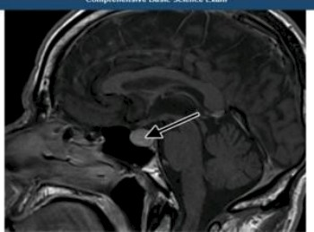

#### ¥69. A s2-yaar-old roman coma to the phyoTclan because of a 8-month hloto of pmgmsslve zooo of perTpnaraz vTslon. OphthalmozogTc axamlnat¥on snows bltemporal hemTanopTa wlth normal fundI and vlaual aculty. A oaglttaT it-weIghed MCI of the brain wIth oontrast Ts anon; the arrow Tndlcataa an abnowazlty. No ourgTcazzy access and asset la maao via a naoaT appmach. whlch of la fozzowlng #Tnuaa# muat be traversadP

The Correct Ans we • is . 0. Sphenold

The annorma 1y inc rated sy the arrow a n to vaginal • weighted I.1Rl of me n•a”n is rely a pitu1ary

ade -aha. whicn can cause n temporal hem”anopia c ue to compression of me os1ic chiasm. To a cess a-c reseE11ne mass via a nasal anproaE n, Ine snnenoid sinus must be 1raver sec , as it is locates d”et y below the sella tumica, wn”ch houses Ice pituila g and.

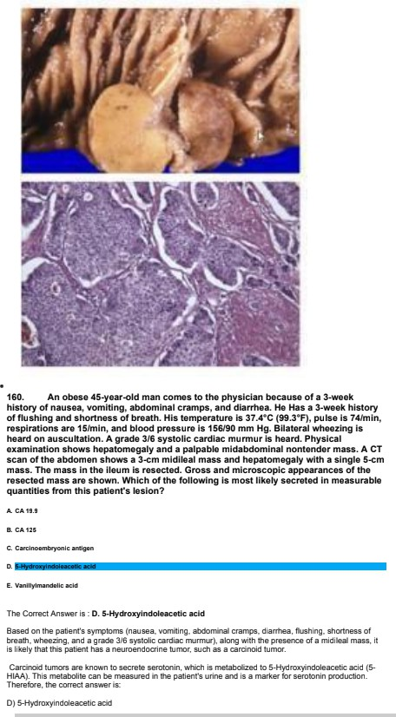

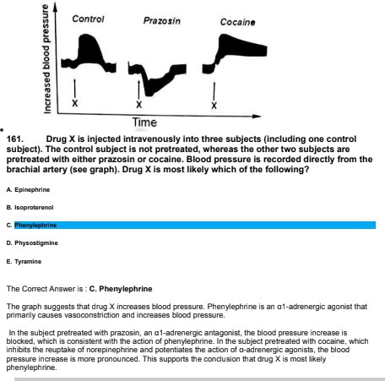

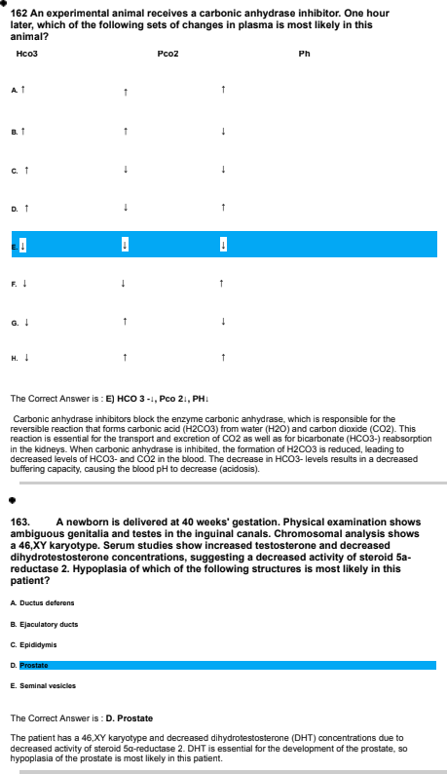



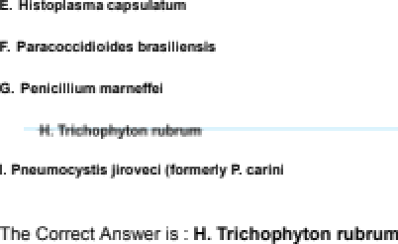

The deaorifmd aye and finds of fi•@aJ hyghw and ardaasprzea a TO-J p+apar&iou as uzineaNrit wiki ânaa infeo6une. aia rn+at rzaomouly uamed by TrfiTi n rr¥zr•ri.



In a naidy of th new of ulteasonogeaphy ter tfin earth detection

The Crzmnt Ann ie . E.

SpeeiEzJry ie the peop<a1Ja oil Irue negative amoug his wilhaJt ¥m uoudiliou. M Ihie uaso. Oiera aia T@







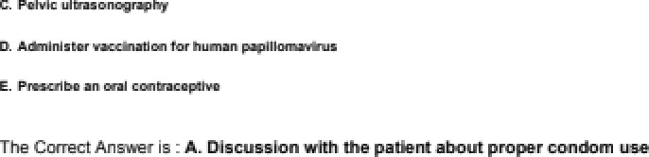

The pa ant has a Very of wkipte mzuâ peNra a and rzarient garuz+usaJ +mviniéa. To pm ha

. il ie nd fa pre aul morally 1zammft@d irrfes 'sne (STIe). LI euueeJng p+o{mr &zn use wgl h@ reds dieriak c'f STIe.



A M•ynarWa man comas to tha pbycklon Wousa of a 2•niomh tilc4ory of



new pnñetafik faerie ln tha etoaia&i •na eoiNl

pncn•onnnpbogm}unct&n. 1s no poñe4nlm ln lha eeopfmgus;

The Crzmnt Ann ie . A. Ersertc gala

The, pagans eye and fit ashalaeia. a dB'onder nharmtm?zed by the abmnoa of







det adorie biarapy6 heioin mJdf+s:in worka by aufmtilutñ@ a k+ugar-aetñ@ ng d ag I. nu ie) , fts Oie ahWr-eztir@ he. This reduue the+vâ eymp1xarie and aavim. Eng diermovery

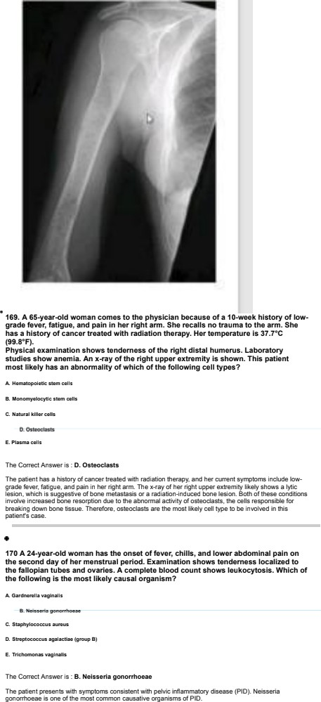



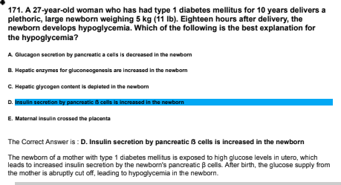

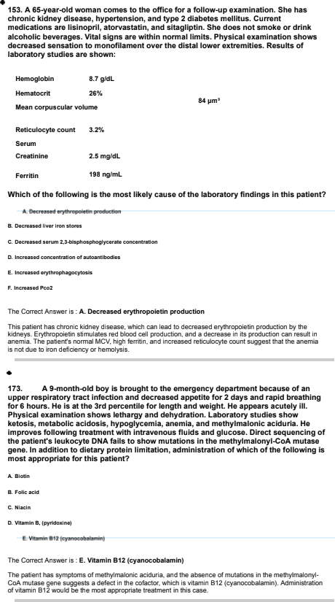

#### T74. An 8-year-of gIn Is bmugnt to la phys¥clan bacauaa of an B-year hlsory of scratchy sin. 6he la at the soth arcentTTe for nelght and eTgnt. Physical examTnatlon shows smooth okTn that Is vazvety to la touch. astendo easlzy. and anape back after mzeasa. Thera as muItTpze thin. stmtcnad scan over the foranaad, azboto. knoaa. and ohlna. Ranga-of- motlon tesfing show nypermoblllty of the hand and Xnae )oInts. Her mower has almlzar flndlngs. GanetTc tesfing of tha patNnt”s lympho tea snows a 1B- nuc&ofida delat¥on In a cozzagen sA# tCOLW4} aIzeTe. The mRNA pWuct of COLW# In both la nucleus and cyopTasm & aosaaaed In cultured am flbmbTasts. Results snow a 6W bvez of mutated mRNA Tn the nuczeua and Of IaveT of mutated mRNA Tn the cyopzasm. Based on tnaoe gndTnga, oleh of the foTToMng dlooaae mechanlama Io most zTkaly In thls patlentP



The Correct Answe • is . B. Decreased etablllfy of mRNA

The ° 6-DME eolide deletion ”n the COL5A• gene resulls ”n to p esence of mutates mRNA ”n the nuMew but ol ”n the cyto oasm. n”s suggests Ifiai 1ne m rated MRNA is unsla oe and is likely degracec before 1 can oe transoomd to me cy1oplasm .

#### ¥7s. A y0-yaar-old man oomes O the phyalclan bacauoe of a ¥-montn history of naavy. paosTng oubsternaz chest paln tnat occurs when he walls up a fTlght of atalrs. The aymptomo ara rallevad by rest. Tna phys¥clan praacrlbaa a dog to aIIavTaw the oymptoma. WTthTn the cezz. la drug acts by broaUng down Into a oompound that blndo to a proteln io Incraaoe TntracezTuzar concentrafions of cGMR. raaultTng In vasodlzatlon. Tn& blndlng moat Tlkaly occur Tn oleh of the &TbMng call zocatlonoP





The Correct Ans we • is . A. Cytoeol

The c @ desc•”bed ”n the qWtion ”s most likely nilQglycerin. whiE n is used to that angina. Nity ycerin ”s bra men c own into n1ric oxide jNO! w 1nin to cell, wn”ch binds to soluble guanylate cyclase in to cytoso . This binding leads to an increase ”n intr aEe u ar concent•aIions of cGMP a-c subsequent y resu1s in

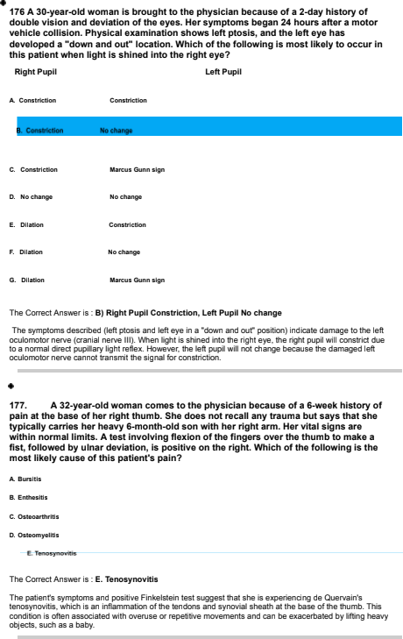

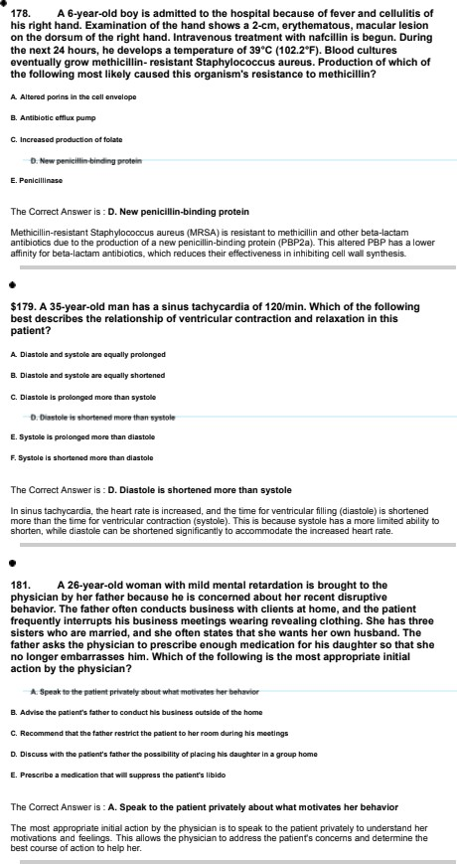

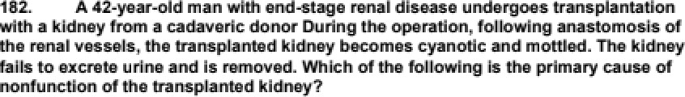



The Crzmut Ann ie . A. Min PM In eagM e +a

The prñriary cariaa of noriheusiou m ¥m I+an planted kidney ie fibrin thabi in die This laads @

### 48a An n • & mnn kaj fevar, •na a ceugfi prmfic6ve of thlck Art&t eputum ln lha hoapftal tor nonrewt of • tilp feacnen. HP tompnmaiee 1s W.7•n (400•€$A chaet z•za9 shows blind hxfiftzatos ln the fownr lobe. 8orum eaidlas chew o cm0nlro cmvcontratfon of OJ 1.. A sputum ctifaiee go

The Crzmnt Ann ie . E. WiaM

The pa and eerrzn aea nine oa 'sn auggaata rmpfi+o nfty, whinh m a kr+cm eide



### o ltcorond peacock nueaa. bha merrily urnfn nl an exptomtory Rpnrotomy to confimi tha dlo 1s of dnulFima•, bul no obnomiNl wan luna. 8hn R 471 cci

The Crzmnt Ann ie . B. F a dix

Thie prk+rrI'a hžrlXzy and gc iou auggaat a fmtžioue dmrdar. She hae racurring epBodea of

hy Iy‹›emi» oa ae nas sva wiih w «<a č› aha. e«a an exnIy ueao ny aia »oi lisa av

avidenue u'f emulinWz The let W ahe ie a heatt saro prz¥eeaional (Ifrmeed ptmticaJ n+ee} alan r spi sx wi«nu da‹›‹a . ea aaivia«e› wio› /a‹iiae aiaad w m lase haeJih<ae-‹e‹a‹ea

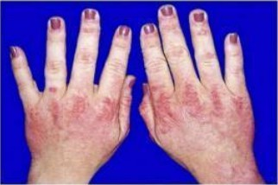



### cash or her &cø and faøds; the each 1s exaoæbetøã ßy eun øxposueø. 8fæ olaø W

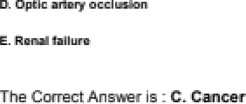

The pa œit has a rash ou W feze and hands Ihat woreas wilh aun azpoaura. she

dižinuky wilh Use that irrøo is her ppei eve aø.The aha Œ of har hands ehowa ś pep+dea. ø'híŒ aro juristic of de rnyoeitšs. Dermæzuyasilie is an intlazirnatrey myopa the





The č¥arual a 34.6 rrEg/L and 147¥ mEq/L is imbued 14a -2{8 J) œ 141 + 2{3J), whinh m wiNin

Appm‹xìniengy ¥0R of vaJuas fall wñ:Łiin one eændard d a a óie mn. Appmxìniengy BSS of vaJuas fall wñ:Łiin two eNndard disable ńOm Iha rneen.



¥e7. A pmv¥ouazy heaTwy s9-year-of man comma to the emergency depanment bacauae of a 4-day history of Saver, #nonnaaa of beach. and productTva cougn. He appears to be Tn modern dlatraaa. Hla tamperawre Io gB.s”C (40¥.#”£}, and moplmtlono are 2Bfmln. Pada oslmat on com alr she an oxygen saturation of BBC . 8roncnlaz bmath sounds are hoard over la rlght lung basa posterlorly wIth egopnony and Incraaoed tactTla fremTwa. A chest *-ray show ight Power lobe pneumonla. Which of la fozzowlng mechanlama Io la moot IIkeIy cause of tna nypoxTa in this gallant?

The Correct Ans we • is . E. Vemllatlon-ps rfusIon mWatcn

The most like y cause of hy ia in lhis patient witn pneu enia is a ventilat on-perfasio n i V'Q1 Tt5N8fE D. The ”nfecâon leads to the f @ of a veoli w th irrf ammato educate. impairing gas exE nape, and resu1iDQ in areas of the ung aim pc•o• vent alion relat ve to perfus”on.

i00. A3-yemr-old boylsbrougñtiomephyslclan becauee#aB-monihhls#ryofa e ayback mfmnsandlng.HIsbro herhad añle# ofmuecleweaWneeeand died of pneumonla at the age of ¥2 yaam. PhysTcaz examTnatlon shows hip gIA& waaXneos.

HP serum craatlne klnaae concantmtlon Ts markad+y Incraa#ed. Tn& patTen€# oymptoma as moat Tlkaly causad by la accumuTatlon of a dafactTva protaln In whIch of the folzowlng zocatlono Tn muscla ceTla?

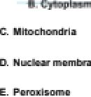

The Correct Ans we • is . B. Cytoplasm

The salient's gym slams and fa oily histop suggest a m ascular crysbo ony, rely Duchenne musE uMr

dyatrophy. The c sease ”s ca ased by a ceficiency of to protein dyst ooh in, wn”Eh is typically locates in Ice cytoplasm of muscle cells a-c prosides st”¥tural suppo n to the Ee mem n•ane.

Yes. A 84-yaar-old roman with chmnTc obatructlve pulmonary dlaeasa comma to the emergency depanment because of a hIntTng a all ¥ hour ago. Sna aays ane Bert zlgnt- heated and saat Mr approxlmateTy 20 oeoonda after an eploode of oevara cougnlng. ghe thinks she may hava coat conocTouanaao. ghe has had nasal congesfion and that TrrTMtlon for be past 3 daya. Sna Io not NXIng any madlcatlons. Wnlcn of the Allowing mechanisms la most zlkeIy moponoTbze Mr tna oyncope7



The Correct Ans we • is . B. Decraased cards outgwt caused by Ineraased Imrathorac ie pceeeura The salient's fa”n1ing toe likBTg W5Mltec PDF Eph sy-cope, which ”s caused oy a cecrease ”n car diac

output due to increases in1ratnoraE”c nressure during severe ro @n”ng. n”s leads to a t•ansJe n1 ceErease in Eeenr al oefusion. caus”@ the sy-cope.

¥s0. A 4-yoa r-old boy Ts brought to la physlc Ian for a rouMna examTnatlon. Ha haa a hTato of daveTopmental delay. mNAaa Nnguage development, hypamcMvTty, and auMatlc WhavTor. Ha apeaks only about 20 sofa. A mammal unc& has manMT mtaoatTon. PhyslcaT esamlnatTon show a Tong ice and large ears. GanatTc atudlaa ahow a mutation In tha s’ untransNted mgTon of tha UMTS gene on tha X chromosome. Molecular atudTes show more Can TO CGG repeats Tn UMTS Whlch of the Allowing geneMc mechanlama eat accounts for the bss of DMRB gene pmduct acMvTty Tn thTa patlentP



The Correct Answer is . B. DMA nypermathyalon

The patient has FragJe X syndrome. causeo by a n expanson of CGG repeats in Jhe 6’ untrans ated regio n of the FfdR1 gene . This expansion leads to ONA hy@rmelhylat on add EonseqweM Ira nsonpâond silBnE ing of the gene, resultirg in a loss of FHR1 gene product BE1tvi1y.

i91. A31-yearoldnuWgavdwomancomesioTephyscanbecaueesheand har huaband have not been able O concelva Mr the past 3 yaam. Her husband has can avaTuaNd, and no problems mara found. Sha haa an intact

hypothaTamTc-pltuTta - ovarlan asTa, and har aewm aatrogan ooncentratTon la wlthTn the reference range. ClomTphene therapy Ta sMrtad. Whkh of tha &TToMng elects la most TTkaly to occur Tn thTa patlant?

#### A z¥o# %kiiio z @‹bo Edna m

•' '••"^'W ^ •" W re ei-



The Correct Answer is . B. Deeraaeed InhIblbsry eabogen feaabank on to pituitary glend

Clam iphene is a seleolive esPopen receptor mooUalor fSE9MI that 6Et5 by blockir+g estrcqen receptors in the /pothalamus and piM4ary glar+d. Tn +s reoMEW Estroqen-mediated negaâve feedbwk, leading la increased seEreâo n of foiiiEie-stimUaiing hon none jFSI-i1 ar+d IuJeinizinp more ‹LI-i1, when stimulate foiiiEUa development and axialon.

¥s2. A 48-yaar-old man wgh a g0-year history of type 4 dIaWtes meIITtua oomea to k e physk Ian bacauaa of la audden onaet   vlaTon. OphthaTmoToglc examTnatlon she no abnormaTTtlea escept Mr waaXnaaa of abductbn of the laft eye. Vvñlck of he folio Ing ie he mos llWelycauee oT Te developmen ofdouble vâbnlntWspadet



The Correct Answer is . B. Diabetic mononeurogat y

The patient's double vrsion is likery due to diabetc moroneurop athg, whch n ERP **tso66D** E**F6ntBT** palsies. in thrs case, me affected nerve rs Ine abducens nerve j era nil nerve ii I. vmich controls me lateral recM +nusEle respons ale for eye abduct on.









aMae Iago,mm ‹azWooae i‹a ibł‹ora. WW ‹u ‹fmNaming d‹uøa io noat ii zo bo jMer Hiv atzam in öaa



